APPENDIX I: IPA CONSULTATION

PROJECTS FEBRUARY 2020

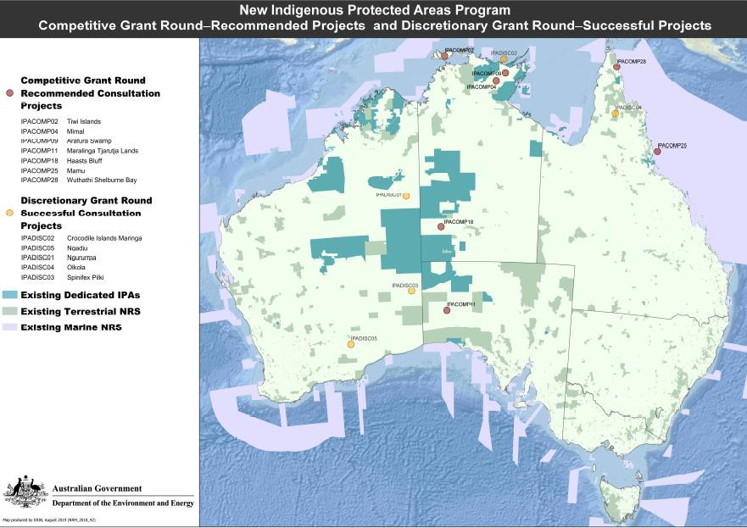
Figure I. 1 The 12 new IPA Consultation Projects as at February 2020
Source: Department of Agriculture, Water and the Environment. https://www.environment.gov.au/system/files/pages/1d88a56f-c0a4-49a3-8b48-16e1e9013755/files/map-new-ipa-program- rounds-projects.pdf

Tiwi Islands, north of Darwin, Northern Territory (Tiwi Land Council)
750,000 hectares. The Tiwi islands are a biodiversity hotspot with at least 20 EPBC Act listed threatened species including the Brush-tailed Rabbit-rat, Northern Brush-tailed Phascogale, Butler's Dunnart and Eastern Curlew. The proposed IPA contains extensive tall tropical savanna forests, a large number of rainforest patches and coasts supporting marine turtle nesting, seabird rookeries and migratory shorebirds. The project will be managed by the Tiwi people and supported by Tiwi Indigenous rangers.
Haasts Bluff, south-west Northern Territory (Central Land Council)
Almost 4 million hectares. Spanning traditional Country of Pintupi, Luritja, Aranda and Warlpiri people, the IPA will improve connections between a cluster of protected areas that together conserve 40 million hectares of arid Country in the NT, SA and WA. The project includes a focus on protecting species of cultural and environmental significance including the EPBC Act listed threatened Princess Parrot, Central Rock Rat, Black-footed Rock-wallaby, Bilby and Great Desert Skink. The project will be supported by the Anangu Luritjiku Aboriginal Rangers.

Mamu, Wet Tropics, far north Queensland (Mamu Aboriginal Corporation)
60,000 terrestrial hectares and over 300,000 sea Country hectares. The proposed IPA includes foothills and coastal wetlands, ranges, islands, World Heritage listed national parks and sea Country within the Great Barrier Reef Marine Park. The area is considered a hotspot for Australian possum diversity and also supports a significant number of threatened species including the EPBC Act listed Southern Cassowary and the Ant Plant (Myrmecodia beccarii), one of 30 plants prioritised under Australia’s Threatened Species Strategy. A major focus for the Mamu people will be to develop co-management arrangements for national parks to be included in the IPA.
Arafura Swamp, north-east Arnhem Land, Northern Territory (Arafura Swamp Rangers Aboriginal Corporation)
1.4 million hectares. The core of the proposed IPA comprises a vast pristine Wetland of National Importance. Considered an area of exceptional conservation value, 27 EPBC Act listed threatened species are known or likely to occur in the proposed IPA including the Eastern Curlew, Northern Quoll, Northern Hopping-mouse, Gouldian Finch and Masked Owl. The project will be supported by five Indigenous ranger teams.
Maralinga Tjarutja Lands, western South Australia (Oak Valley (Maralinga) Aboriginal Corporation)
Over 10 million hectares. A massive IPA proposal including parts of the Nullarbor Plain and Great Victoria Desert. The area is in excellent ecological condition with six EPBC listed threatened species known or likely to occur, including the Malleefowl and Sandhill Dunnart. The project will be supported by an Aboriginal ranger team based at Oak Valley, the largest Aboriginal Community on Maralinga Tjarutja lands.
Mimal, south-east Arnhem Land, Northern Territory (Mimal Land Management Aboriginal Corporation)
1.8 million hectares. Located on the Arnhem Plateau, the proposed IPA includes the headwaters of the rivers feeding into the western Gulf of Carpentaria as well as three major north-flowing rivers. The area supports a large number of species listed as threatened in the Northern Territory and nationally including the EPBC Act listed Northern Hopping-mouse, Northern Quoll, Gouldian Finch, Partridge Pigeon and Leichhardt's Sawfish. An EPBC Act listed Threatened Ecological Community also occurs in the area; the Arnhem Plateau Sandstone Shrubland Complex. The project will be supported by the Mimal Rangers, an experienced Indigenous ranger team established 20 years ago.
Wuthathi Shelburne Bay, Cape York Peninsula, Queensland (Wuthathi Aboriginal Corporation)
155,000 terrestrial hectares and over 800,000 sea Country hectares. The sea Country contains some of the most significant Green Turtle and Dugong habitat in the Great Barrier Reef Marine Park. 26 EPBC Act listed threatened fauna species and 9 EPBC Act listed threatened flora species are known or likely to occur in the
proposed IPA area, including the Eastern Curlew, Southern Cassowary, Palm Cockatoo, Ghost Bat and Haine’s Orange Mangrove. The Harmer River–Shelburne Bay Aggregation located within the proposed IPA is a Wetland of National Importance.
Ngururrpa, south-east Kimberley, Western Australia (Desert Support Services, on behalf of Parna Ngururrpa Aboriginal Corporation)
Almost 3 million hectares. The IPA will provide linkages and connectivity to a number of dedicated IPAs. The area includes habitat for the EPBC Act threatened Bilby and several other EPBC Act listed species.
Ngadju, north of Esperance, Western Australia (Ngadju Conservation Aboriginal Corporation)
4.4 million hectares. A Biodiversity rich area including habitat for two EPBC Act threatened ecological communities and a number EPBC Act threatened species including the Numbat, Red-tailed Phascogale and Curlew Sandpiper. The IPA will result in substantial increased protection of the under-represented IBRA sub- regions of Eastern Goldfields and Western Mallee.
Olkola, central Cape York, Queensland (Olkola Aboriginal Corporation)
Over 770,000 hectares. The proposed IPA includes two jointly managed national parks and will provide connectivity to five other national parks. The area includes habitat for EPBC Act listed species including the Black-footed Tree-rat, Ghost Bat and Masked Owl.

Crocodile Islands Maringa, north-east Arnhem Land, Northern Territory (Milingimbi & Outstations Progress Resource Association)
Over 78,000 terrestrial hectares and 730,000 sea Country hectares. The proposed IPA includes extensive mangrove communities, tidal flats/salt pans, intertidal mud flats, coastal floodplains, monsoon forests, eucalypt open forests, shallow seas and reefs, and a network of near and offshore islands. 18 EPBC Act listed threatened species are known or likely to occur on the proposed IPA and the intertidal mud-flats of the area seasonally support the largest aggregation of migratory shorebirds in northern Australia. The project will be supported by the Crocodile Islands Rangers, an experienced Indigenous ranger team established in 2011.
Spinifex Pilki, south-east Western Australia (Pila Nguru Aboriginal Corporation)
6.2 million hectares. A large and extremely remote IPA proposal. The area spans a north-south transition in pristine ecosystems ranging from the Nullarbor Plain and mulga woodlands of the Great Victoria Desert Nature Reserve in the south, through sand hill and salt lake Country, into the breakaways and hills of WA’s Central Ranges.

