APPENDIX J: SPATIAL MAPPING OF

SELECTED NESP HUB RESEARCH PROJECTS

The brief required SGSEP to map the geo-spatial location of the selected Indigenous research projects of each of the NESP Hubs to ascertain where Indigenous environmental and climate science research has taken place and where there may be geographic gaps in Indigenous environmental and climate science research.
In order to ascertain an understanding of the nature of Indigenous engagement in NESP Hub research activities, SGSEP selected or was guided to 108 projects across all of the NESP Hubs on the basis of having a high level of Indigenous engagement. shows the selected Indigenous NESP projects by Hub that we were able to map against a particular locality. Figure J.1 shows that the majority of projects are located predominantly in northern Australia.

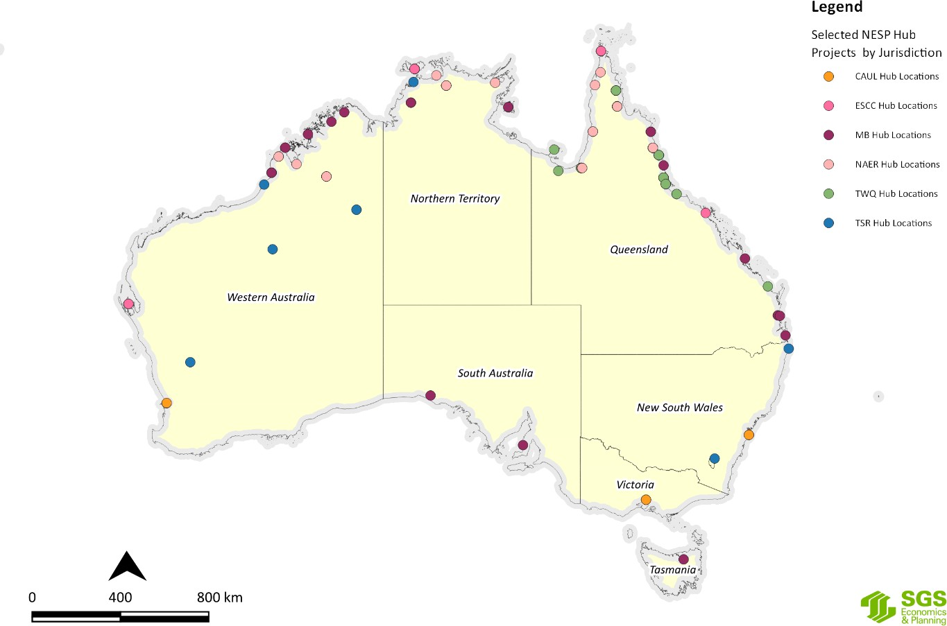
Figure J.1 Selected NESP research projects by Hub as at March 2020
Source: SGS Economics and Planning using NESP Hub Data, 2020

It is important to note that among the 108 projects that we examined in some detail, there are several that are not able to be mapped geo-spatially because they were not focussed on a specific locality, or the

research took place over multiple localities, or the research being undertaken has wider or potentially of national application. The projects not included in this geo-spatial mapping are listed in Appendix K.
In approaching this task, SGSEP also decided that there would be some added value by mapping the selected NESP Hub projects against a number of different thematic layers of geo-spatial information. Using the projects that SGSEP selected or were guided to by the Hubs on the basis of having a high level of Indigenous engagement, we were able to map them against the following thematic layers of geo-spatial information:
- State/Territory;
- Australia’s Marine BioRegions (MB Hub projects only);
- Australia’s Terrestrial BioRegions;
- NRM Regions;
- Indigenous Protected Areas;
- Indigenous owned and managed land;
- Indigenous managed land;
- Indigenous co-managed land; and
- Indigenous special rights (i.e. native title determinations).
The selected thematic layers of geo-spatial information depended on the availability and compatibility of the relevant geo-spatial data.
The maps in Appendix J show the location of the selected NESP Hub projects against various environmental or other significant layers to ascertain an understanding of the relationship between the NESP Indigenous research activities and the other layers of geospatial information or theme. It is important to note that the maps in this Appendix do not reflect all of the NESP Hub Indigenous research projects. However, the maps can be read as generally indicative in terms of their relationship to a particular layer of information or theme.
In the Maps in this Appendix, we refer to the selected NESP Hub projects as ‘Selected Indigenous Hub
projects’ as a simple way of referring to the selected projects for this review. It does not mean that all of the selected projects were necessarily co-designed or co-produced by Indigenous peoples or were solely Indigenous focussed.
It is also important to note that three of the Hubs have responsibilities for a particular geographic area, as follows:
- The geographic scope of the NAER Hub’s research is on Northern Australia only.
- The geographic scope of the TWQ Hub’s research is focussed on the Great Barrier Reef, the Torres
Strait and other tropical waters.
- The geographic scope of the CAUL Hub is on urban environments in our major cities and regional centres.
The combination of these geographic factors therefore skews the focus of the NESP predominantly toward northern Australia.
From the following analysis, we make some crucial observations about the connections, or lack thereof, between the selected environmental and climate science research projects undertaken by the NESPS and the various layers of geo-spatial information.

State/Territory
Figure J.2 to Figure J.7 map the number of Indigenous research projects by Hub by State and Territory. This analysis shows there are more Indigenous research projects in in the north of Australia and less projects in the southern parts of Australia. The maps show that the jurisdictions with the least number of Indigenous NESP Hub research projects are the Australian Capital Territory, South Australia, Tasmania, New South Wales and Victoria.

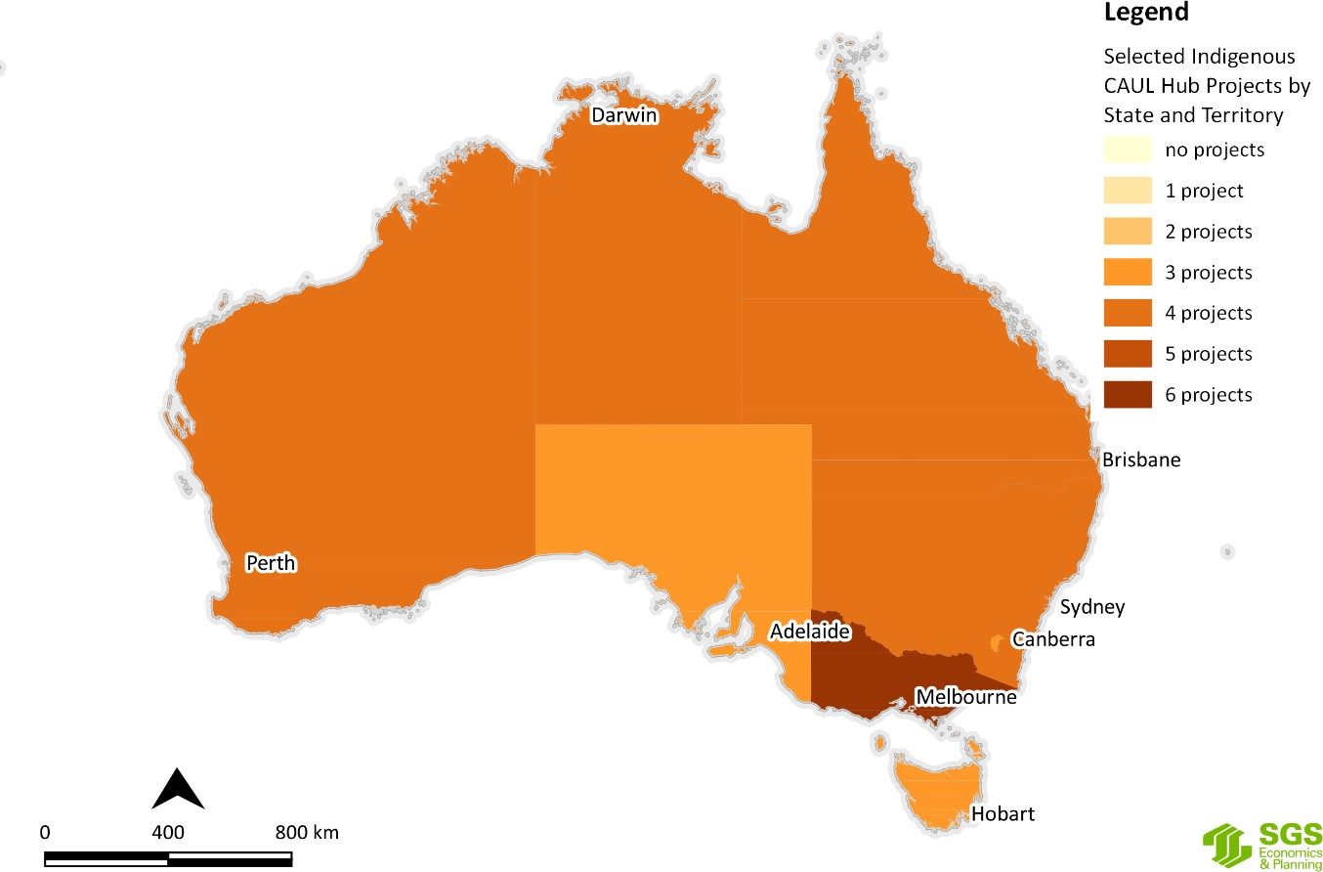
Figure J.2 Selected CAUL Hub research project locations by State and Territory
Source: SGS Economics and Planning utilising NESP Hub data, 2020
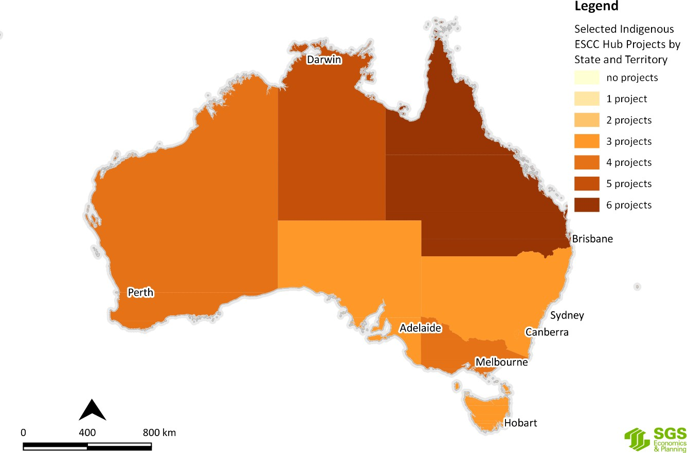
Figure J.3 Selected ESCC Hub research project locations by State and Territory
Source: SGS Economics and Planning utilising NESP Hub data, 2020

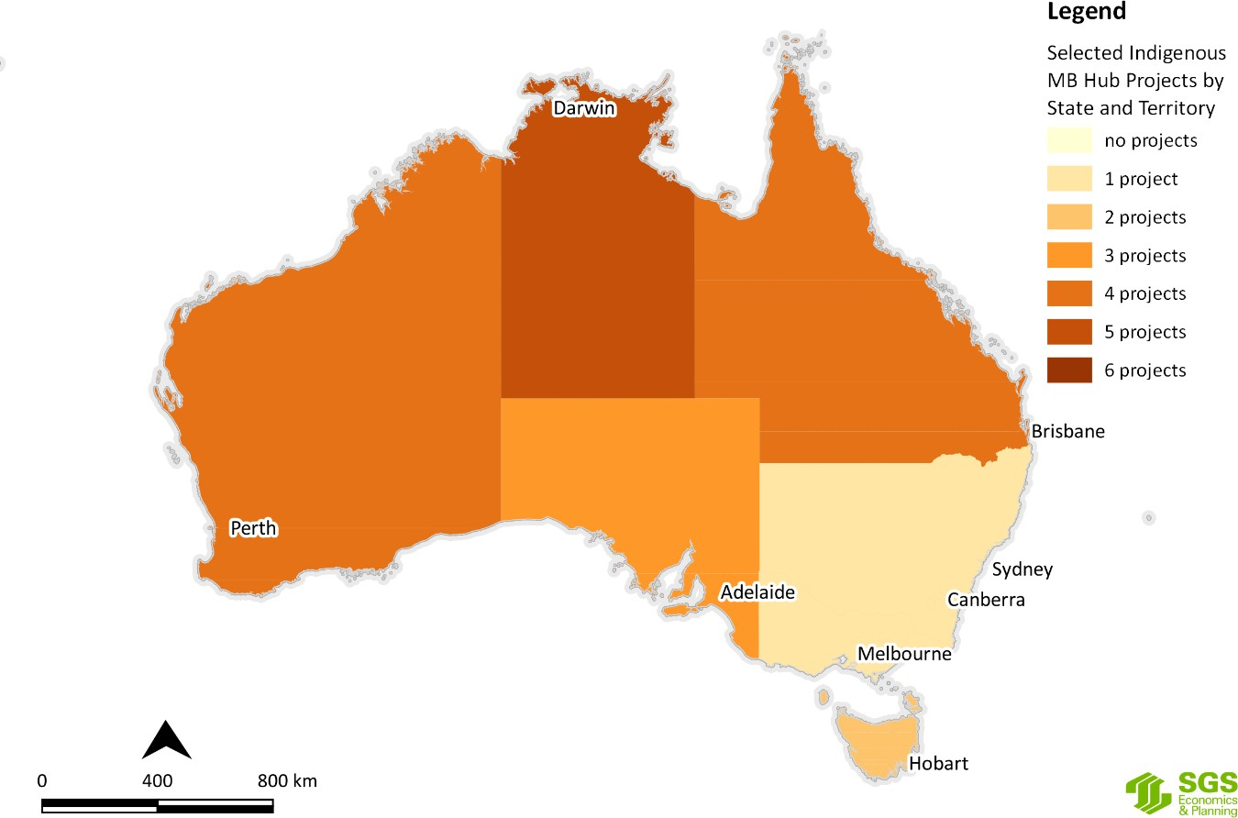
Figure J.4 Selected MB Hub research project locations by State and Territory
Source: SGS Economics and Planning utilising NESP Hub data, 2020
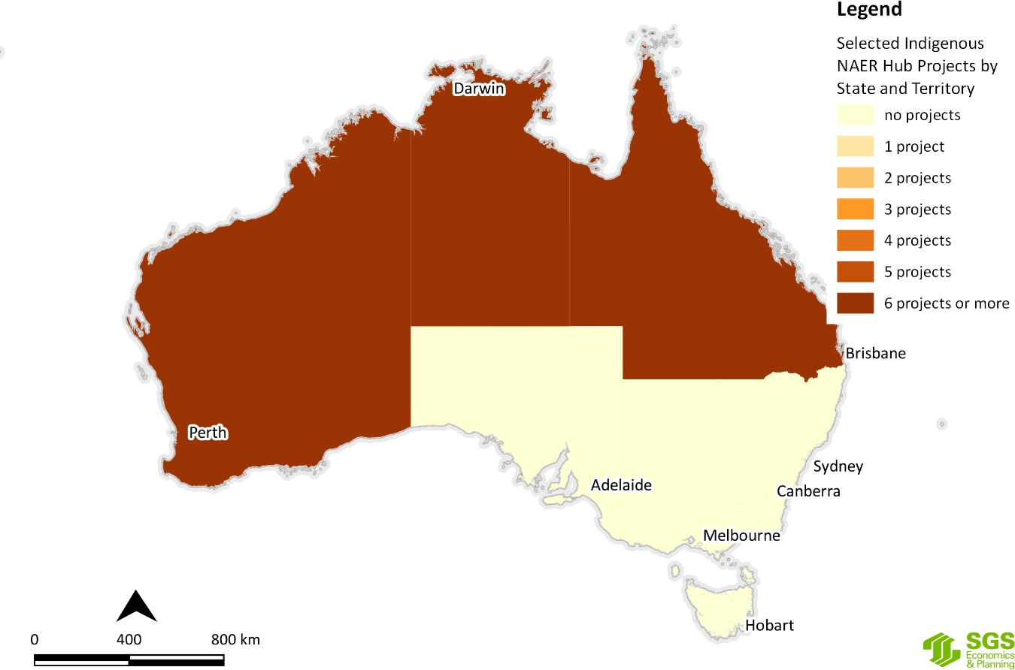
Figure J.5 Selected NAER Hub research project locations by State and Territory
Source: SGS Economics and Planning utilising NESP Hub data, 2020

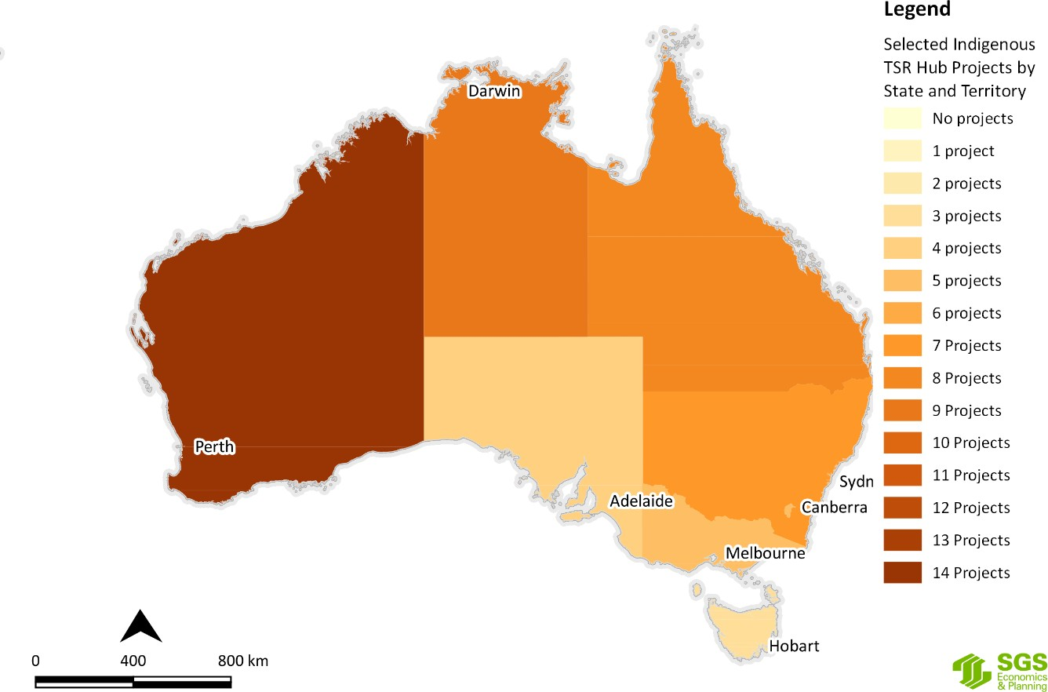
Figure J.6 Selected TSR Hub research project locations by State and Territory
Source: SGS Economics and Planning utilising NESP Hub data, 2020
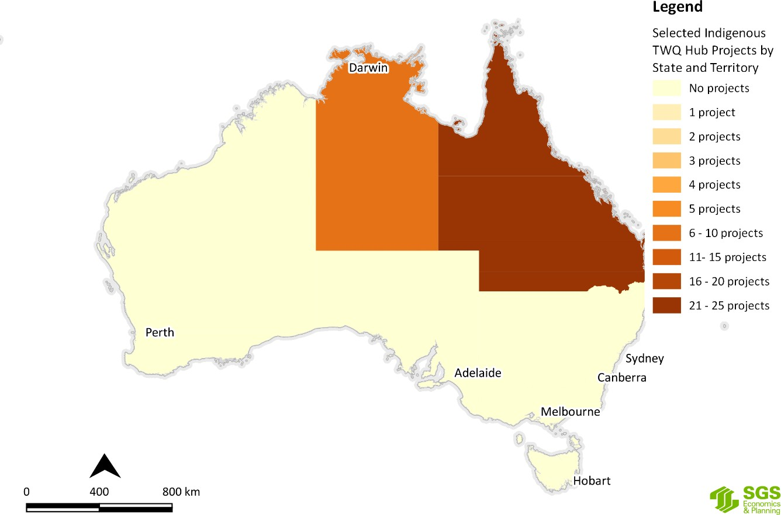
Figure J.7 Selected TWQ Hub research project locations by State and Territory
Source: SGS Economics and Planning utilising NESP Hub data, 2020

Australia’s Marine BioRegions
The framework for Australia’s Marine Bioregions, the National Representative System of Marine Protected Areas (NRSMPA) and Australia’s Marine Parks (AMP) (Figure H.12) was discussed in part of Appendix H. The Integrated Marine and Coastal Regionalisation of Australia (IMCRA v4.0) (Figure H.11) is a spatial framework for classifying Australia's marine environment into bioregions which form the basis for the development of a National Representative System of Marine Protected Areas (NRSMPA).
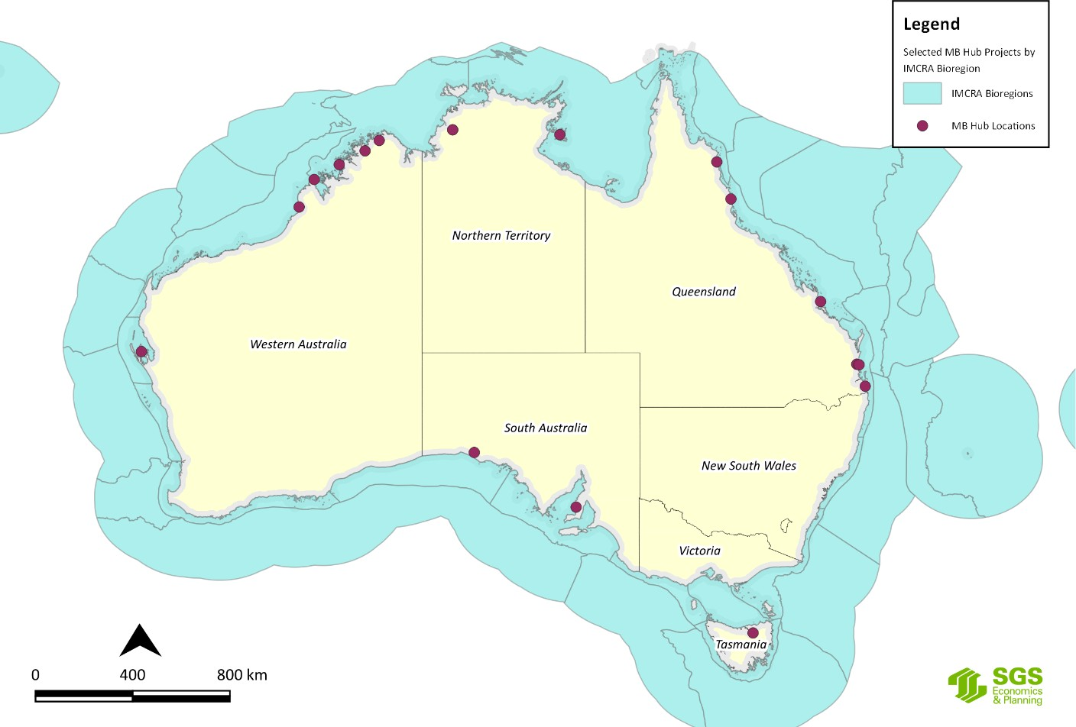Using Figure H.14 in Appendix H, Figure J.8 maps the Marine Biodiversity Hub’s selected Indigenous research projects against the IMCRA Bioregions.²⁴ Figure J.8 shows that most of the MB Hubs projects are concentrated in the tropical waters and Transition areas with fewer projects in the subtropical waters and cold temperate waters, reflecting the Australian Government’s general policy interest in developing the north, as well as the marine areas under the greatest pressures and the areas of strong interest by TOs.
Figure J.8 MB Hub selected research project locations by IMCRA Bio Regions
Source: MB Hub data and DAWE data, 2020.
Using Figure H.11 in Appendix H, Figure J.9 maps the location of the Marine Biodiversity Hub’s selected Indigenous research projects against Australia’s Marine Bioregion Planning Areas. Figure J.9 shows that the MB Hub’s projects are spread across most of the Marine Park areas in the northern and western areas of Australia in the waters around Tasmania, but none in the waters around South Australia, Victoria and New South Wales.

24 Unfortunately, it was not possible in the time available to map the other NESP Hub projects against the IMCRA database.

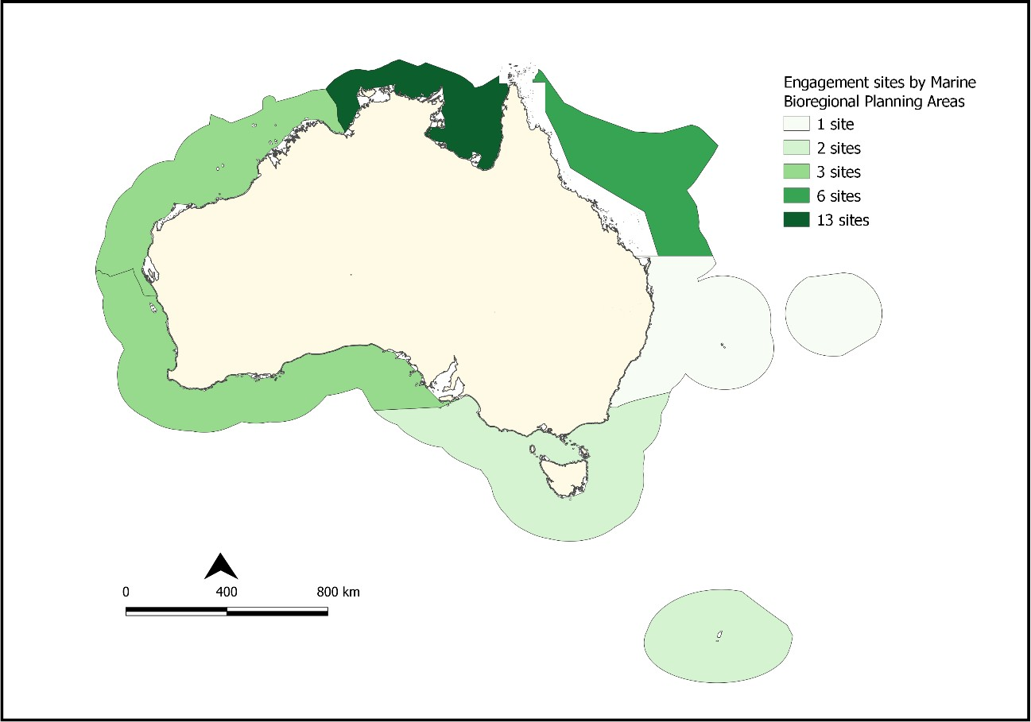

Figure J.9 MB Hub Selected research project locations by Marine Bio Region Planning Areas
Source: MB Hub 2020.
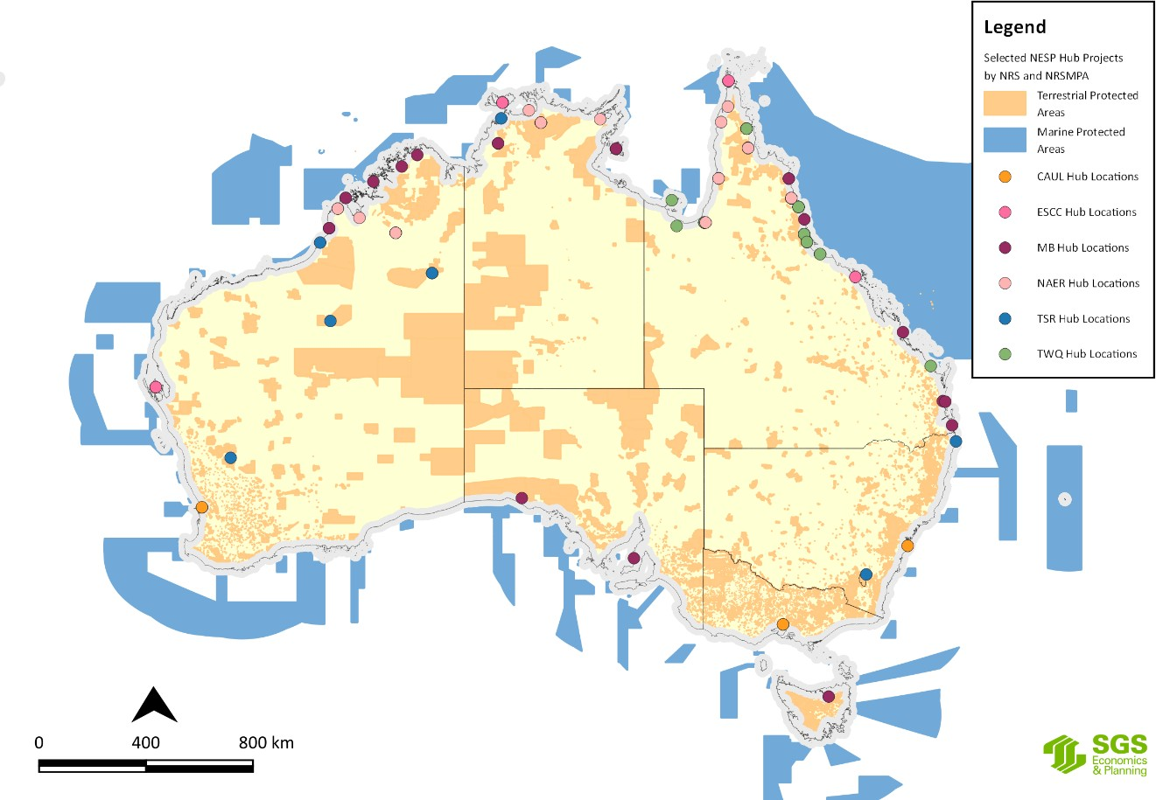
Figure J.10 Selected NESP Hub research projects by NRS and NRSMPA
Source: SGS Economics and Planning utilising NESP Hub data, 2020

Figure J.10 shows all of the selected NESP Hub research projects against the National Reserve System (NRS) and the National Representative System of Marine Protected Areas (NRSMPA). The NRS and NRSMPA comprise Australia’s terrestrial and marine protected areas.

Australia’s Terrestrial BioRegions;
The framework for Australia’s Bioregions and NRS was discussed Appendix H. The Interim Biogeographic Regionalisation for Australia (IBRA) (Figure H.14) and Terrestrial Ecoregions of Australia (Figure H.15) are a spatial framework for the systematic development of a comprehensive, adequate and representative NRS in Australia. The IBRA classifies Australia's landscapes into 89 large geographically distinct bioregions based on common climate, geology, landform, native vegetation and species information.
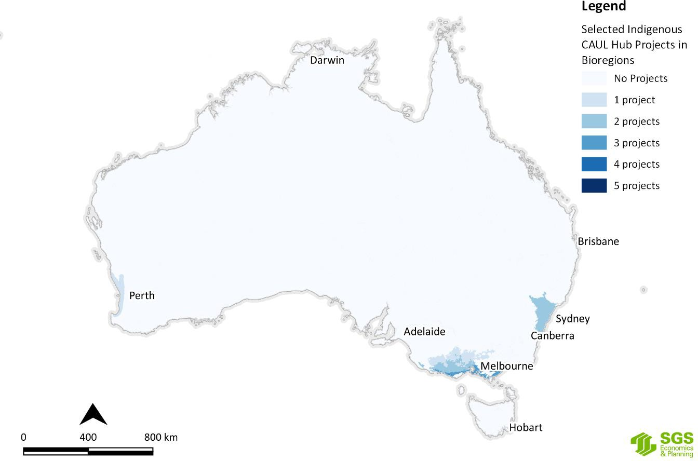Using Figure H.14 and Figure H.15 in Appendix H, Figure J.11 to Figure J.16 map the selected NESP Hub Indigenous research project locations by IBRA regions. A closer inspection of the data behind these maps shows that some of the NAER Hub and TWQ Hub projects are in areas that are under-represented in the NRS, especially in Queensland and the Northern Territory and SGSEP was informed by the NESP Hubs that the research outcomes are adding valuable knowledge and understanding about various environmental matters in these areas.
Figure J.11 Selected CAUL Hub research project locations by IBRA
Source: SGS Economics and Planning utilising NESP Hub data, 2020

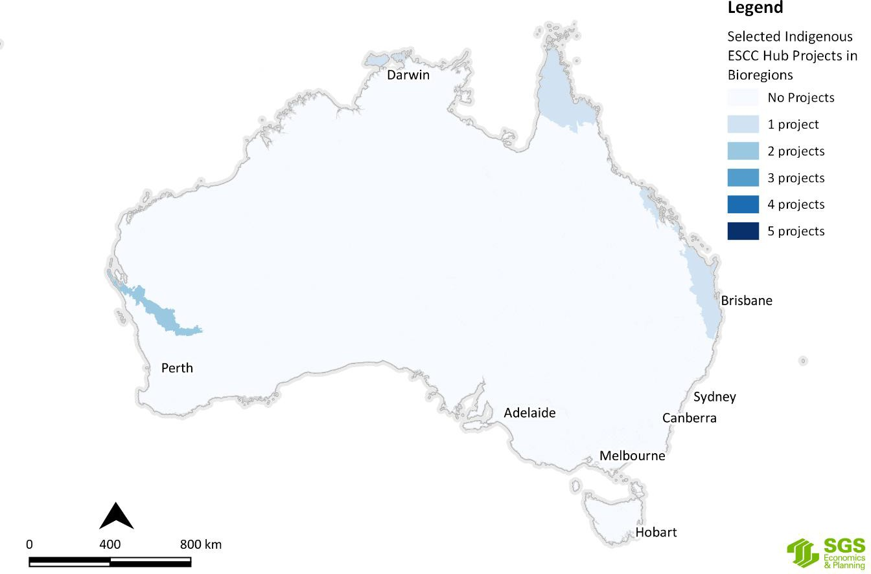
Figure J.12 Selected ESCC Hub research project locations by IBRA
Source: SGS Economics and Planning utilising NESP Hub data, 2020
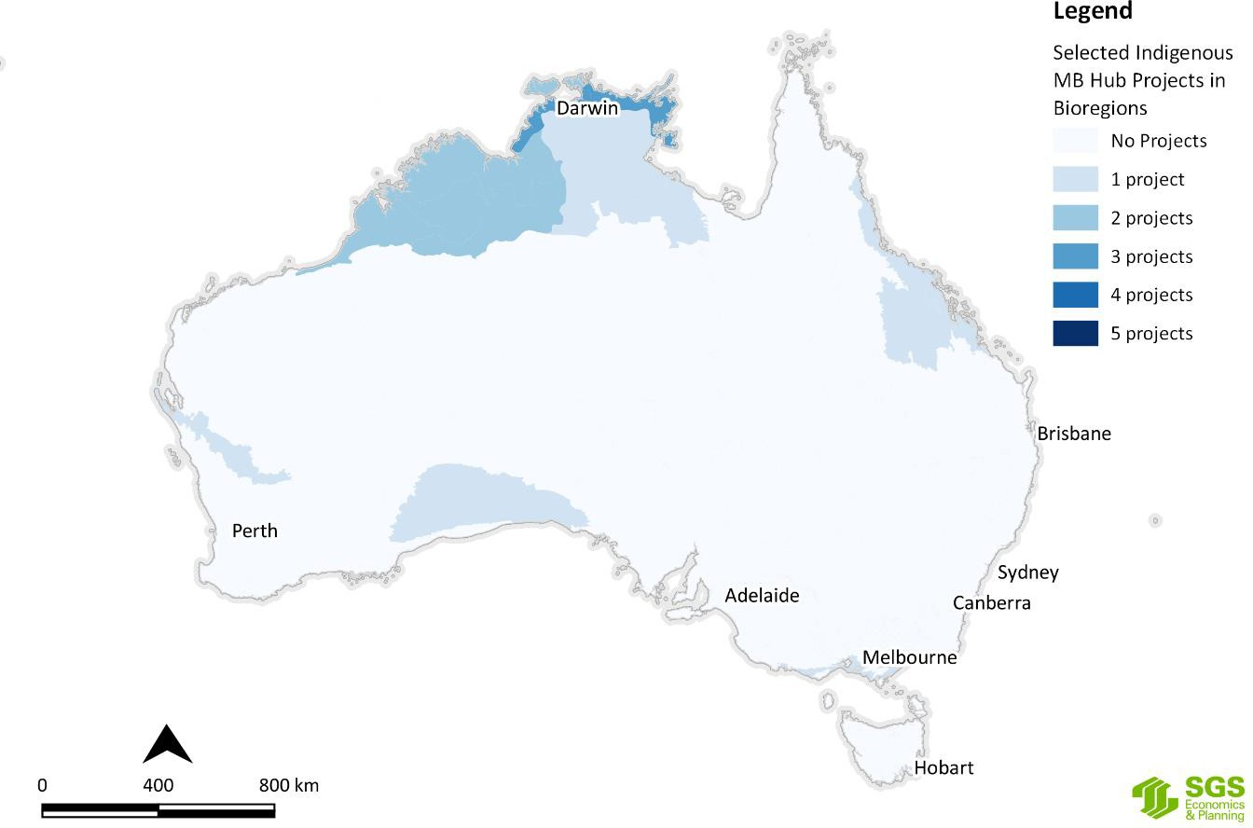
Figure J.13 Selected MB Hub research project locations by IBRA
Source: SGS Economics and Planning utilising NESP Hub data, 2020

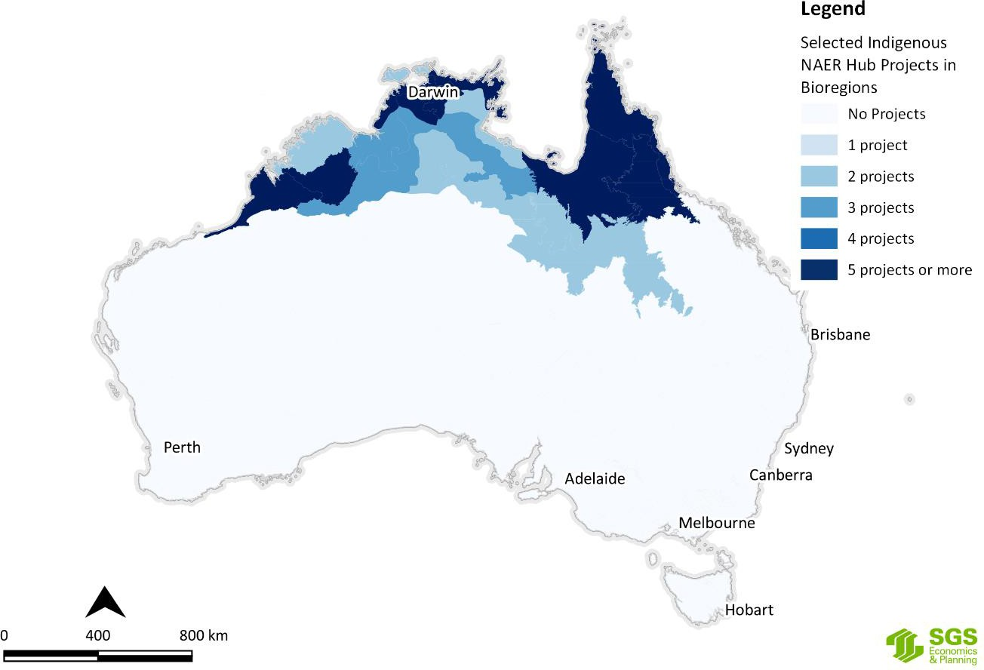
Figure J.14 Selected NAER Hub research project locations by IBRA
Source: SGS Economics and Planning utilising NESP Hub data, 2020
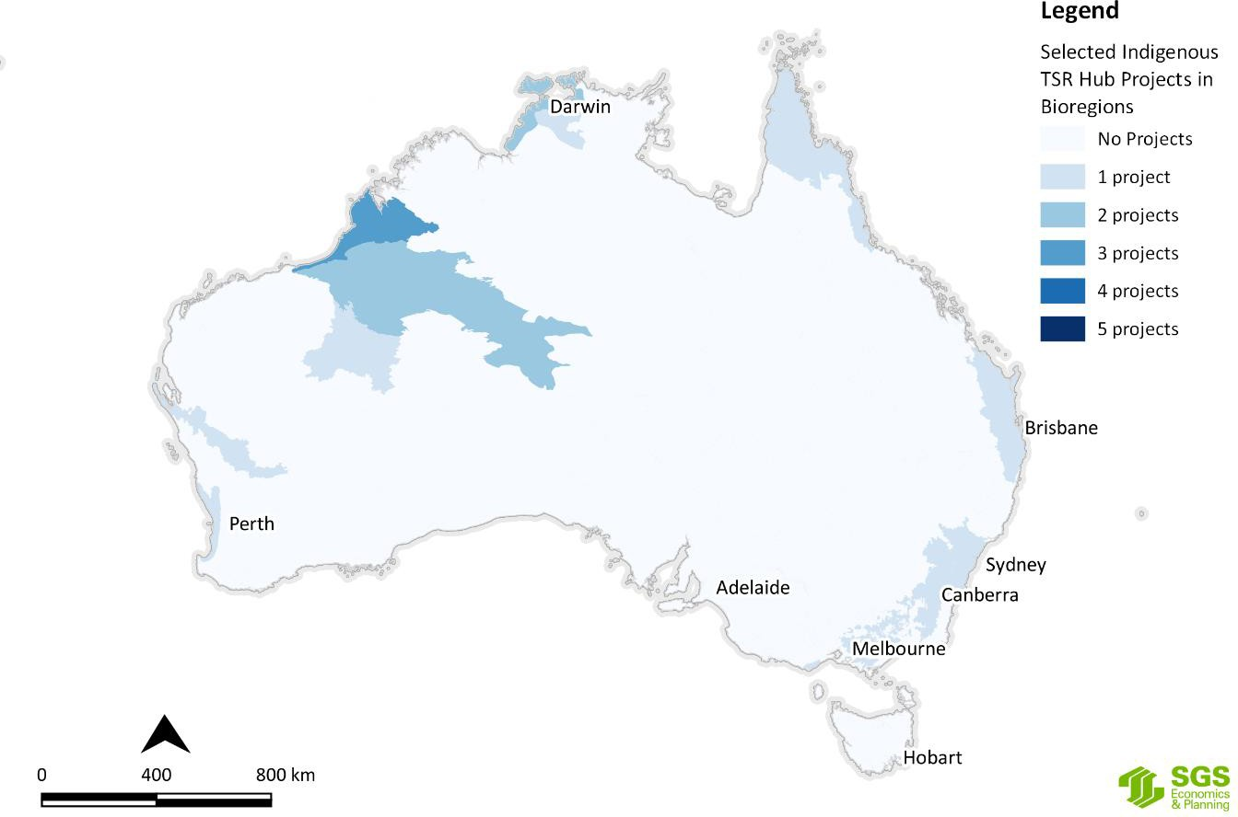
Figure J.15 Selected TSR Hub research project locations by IBRA
Source: SGS Economics and Planning utilising NESP Hub data, 2020

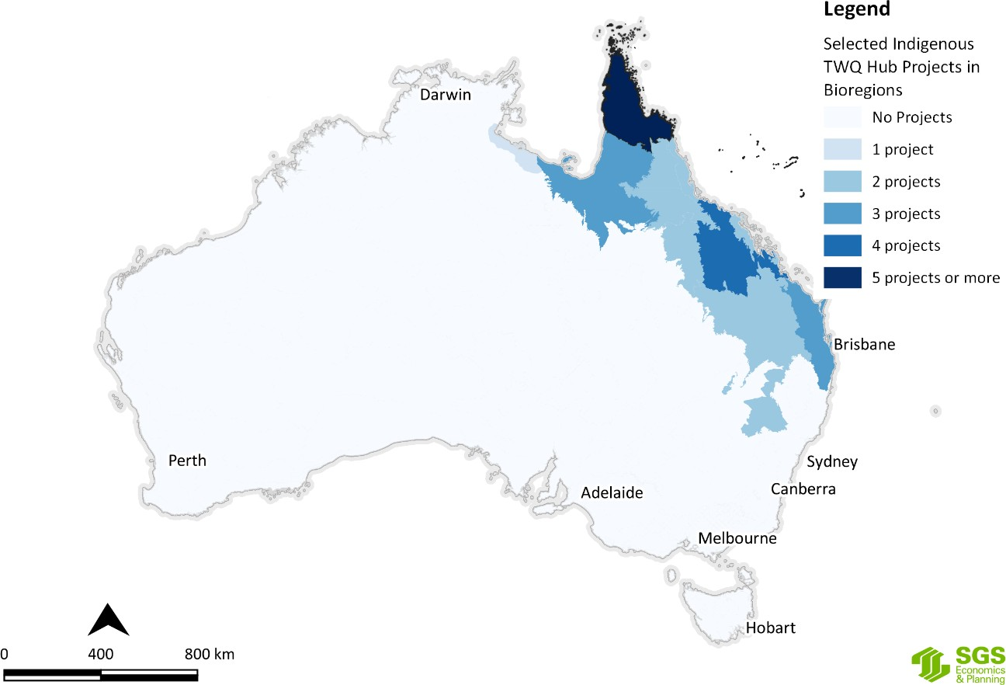
Figure J.16 Selected TWQ Hub research project locations by IBRA
Source: SGS Economics and Planning utilising NESP Hub data, 2020

Indigenous Protected Areas
As discussed in Appendix H, there are 76 dedicated IPAs in Australia, covering approximately 67 million hectares and accounting for more than 45 per cent of the National Reserve System's total area (Figure H.17). There are also 12 more sites currently under consultation (see Appendix H for details).
Figure J.17 shows the selected NESP Hub research projects on a map of the IPAs across Australia.

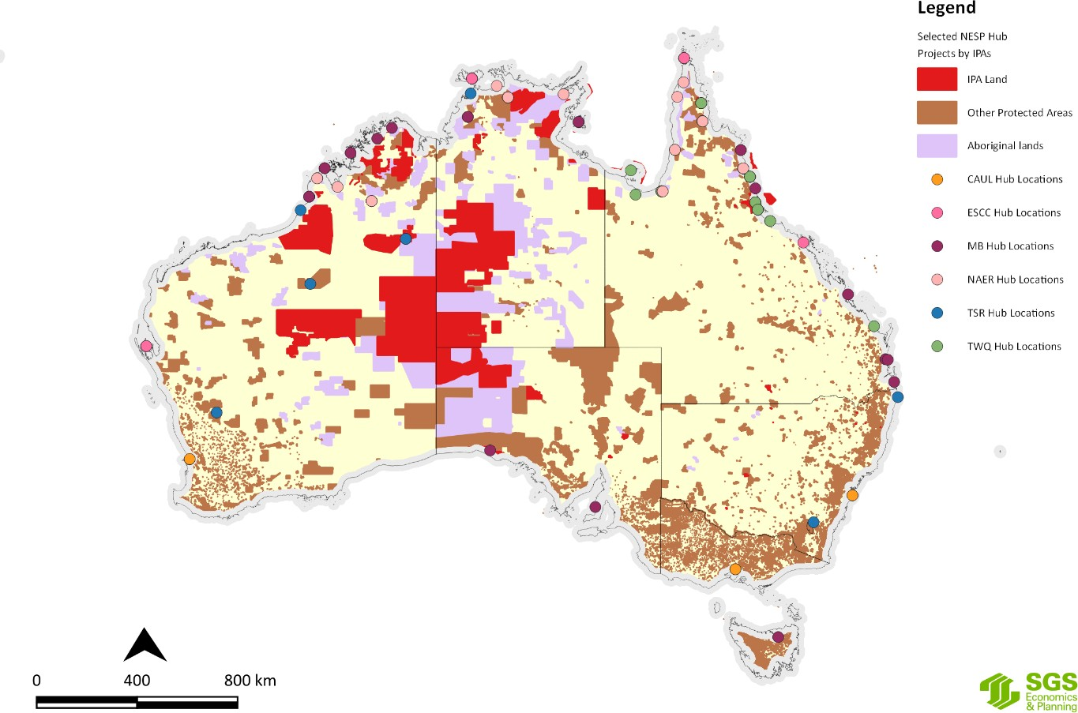

Figure J.17 Selected NESP Hub Projects by Indigenous Protected Areas (IPAs)
Source: SGS Economics and Planning utilising NESP Hub data and DAWE data, 2020
Using Figure H.9 in Appendix H, Figure J.18 to Figure J.23 show that for some Hubs there are a large number of projects involving several IPAs. For example, the NAER, ESCC and TSR Hubs undertook several Indigenous research projects that had a national focus and therefore related to more than one IPA. IPAs are important to Indigenous Australians because the declaration of an IPA is undertaken in consultation with the relevant TOs and a management plan has to be prepared by the entity that will be appointed to manage the IPA before the declaration is finalised. This means that an IPA Management Plan carries a considerable degree of authenticity about what the TOs regard as threats to the place and its values and how a place should be managed. IPA Management plans may also identify matters where research is required either to better understand the nature of threats or how to improve monitoring and management techniques to ensure the place continues to protect the values for which the place was dedicated as an IPA. For these reasons the IPA Management Plans are examined in more detail in Appendix H.

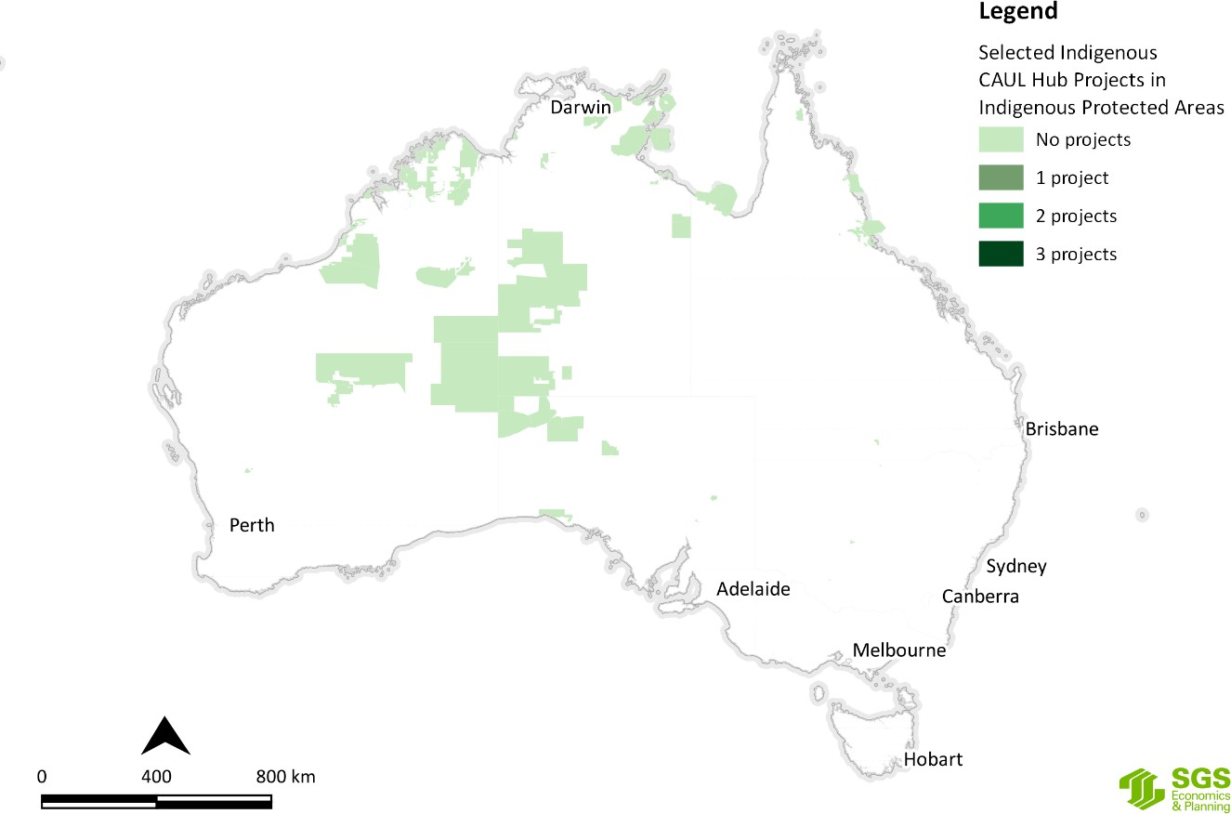
Figure J.18 Selected CAUL Hub research project locations by IPAs
Source: SGS Economics and Planning utilising NESP Hub data, 2020
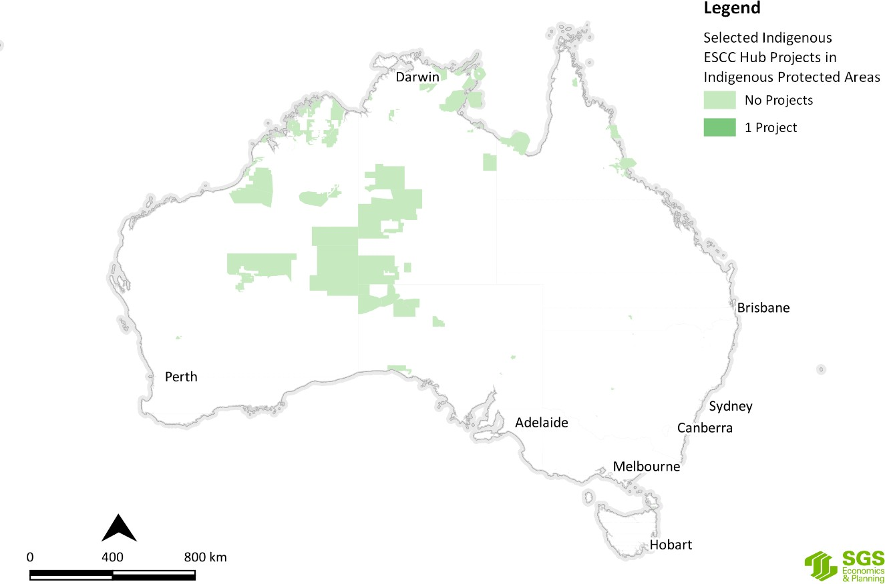
Figure J.19 Selected ESCC Hub research project locations by IPAs
Source: SGS Economics and Planning utilising NESP Hub data, 2020

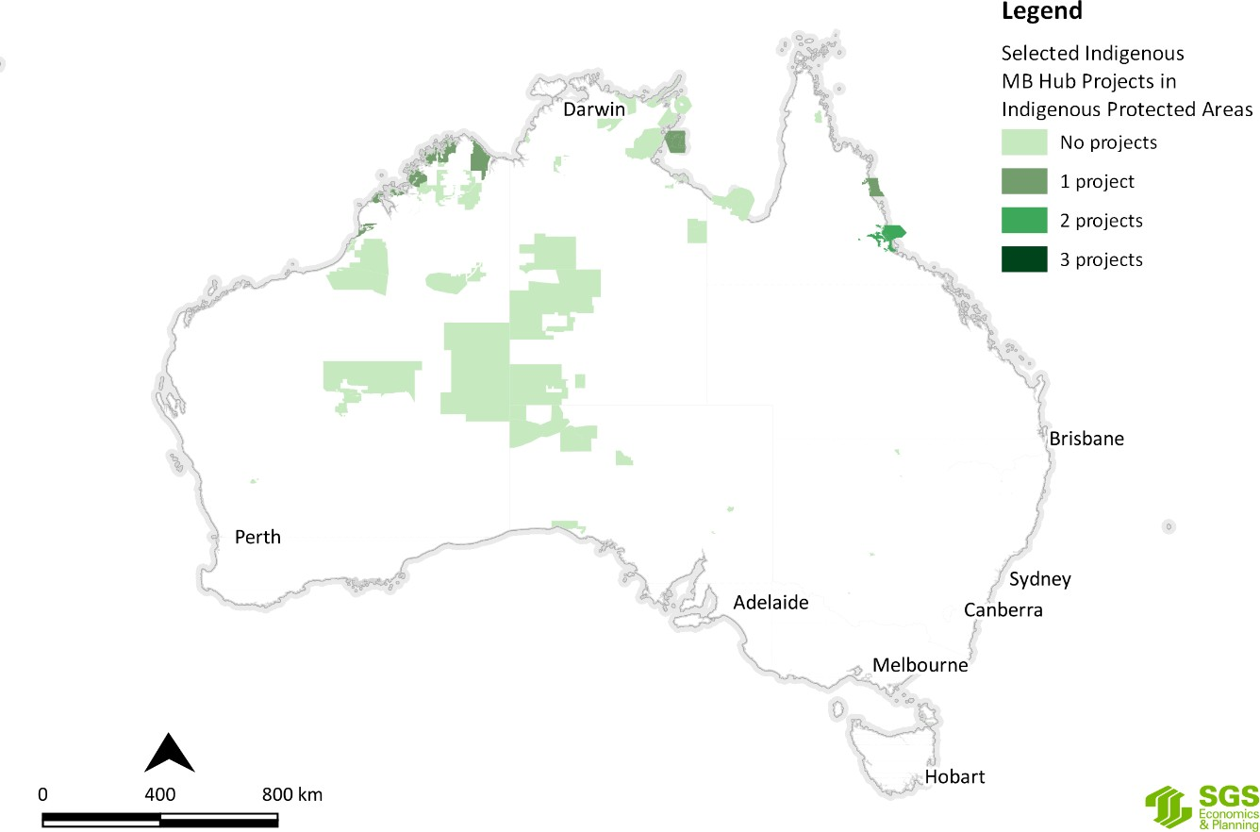
Figure J.20 Selected MB Hub research project locations by IPAs
Source: SGS Economics and Planning utilising NESP Hub data, 2020
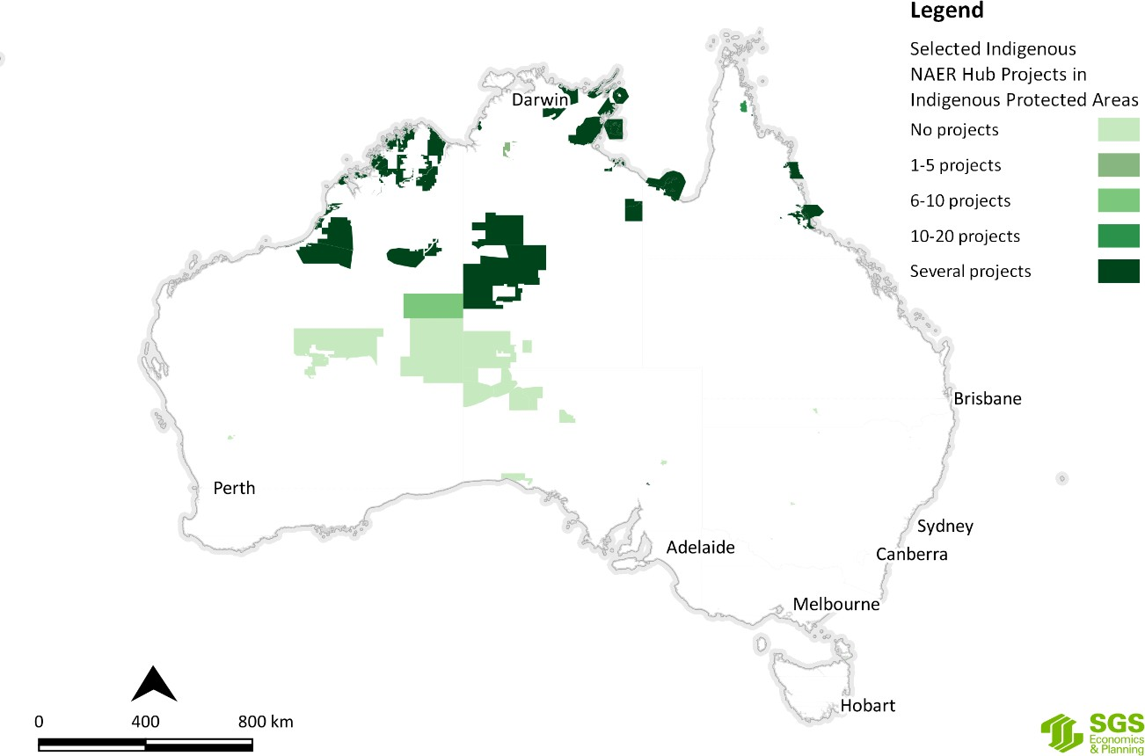
Figure J.21 Selected NAER Hub research project locations by IPAs
Source: SGS Economics and Planning utilising NESP Hub data, 2020

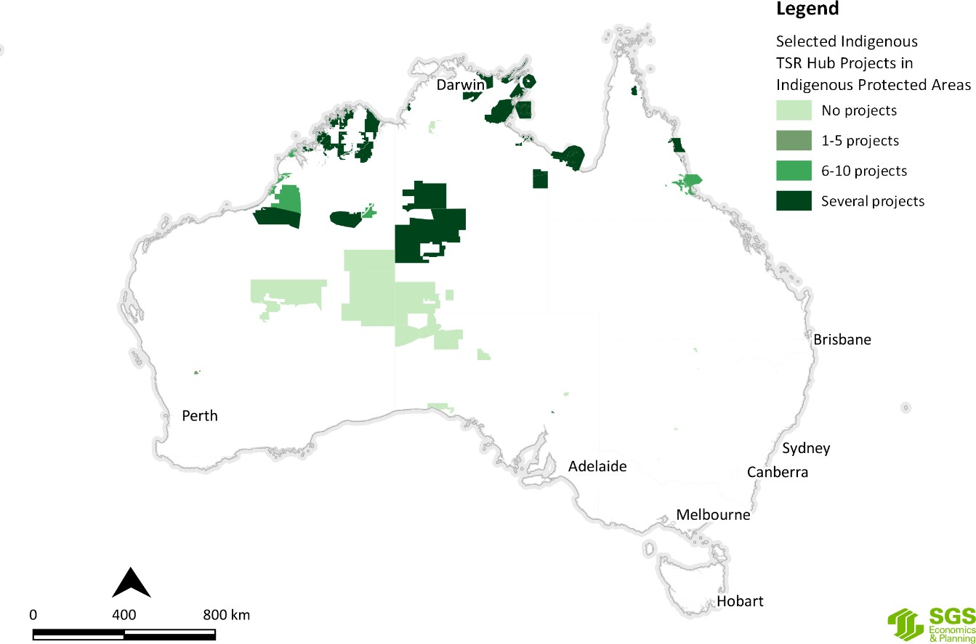
Figure J.22 Selected TSR Hub research project locations by IPAs
Source: SGS Economics and Planning utilising NESP Hub data, 2020
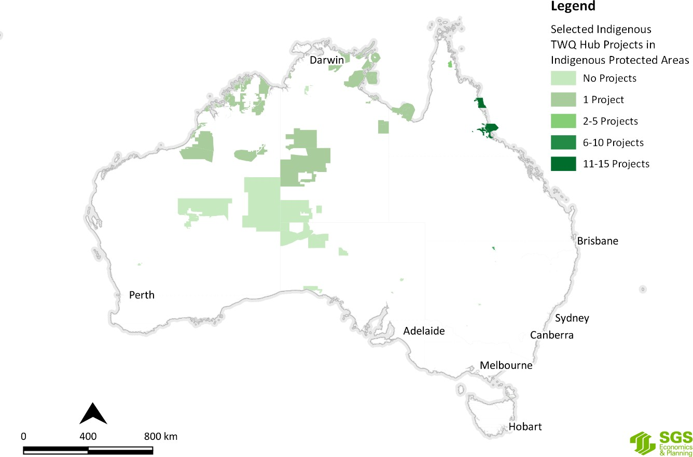
Figure J.23 Selected TWQ Hub research project locations by IPAs
Source: SGS Economics and Planning utilising NESP Hub data

NRM Regions
As discussed in Appendix H, the Regional Land Partnerships component of the National Landcare Program provides funding for 49 management units across Australia (Figure H.20) to deliver particular outcomes, including engagement with Indigenous peoples and the utilisation of their IEK for the achievement of environmental and agricultural outcomes.
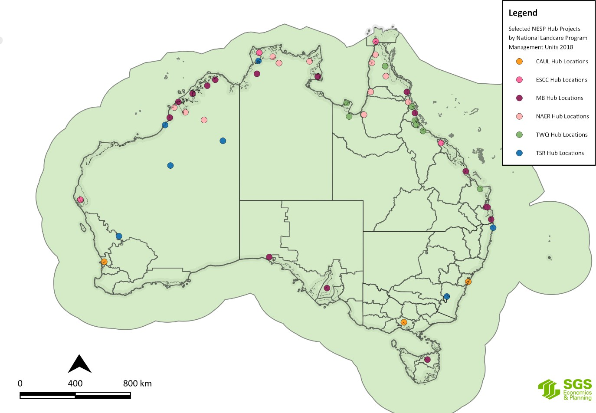Figure J.21 shows the selected NESP Hub research projects against the National Landcare Program (NLP) Management Units.
Figure J.24 Selected NESP Hub research projects by National Land Care Program (NLP) Management Units
Source: SGS Economics and Planning utilising NESP Hub data, 2020
Utilising the interactive map of the 56 regional NRM organisations²⁵ in Appendix H, Figure J.25 to Figure J.30 show that many of the NRM Regions have a very low number of Indigenous NESP Hub research projects in their respective areas of interest. What this suggests is that there is little or no correlation between Indigenous NRM projects funded under the National Landcare Program and Indigenous NESP Hub research activities and/or collaboration on matters of common interest or concern.

25 http://www.nrm.gov.au/indigenous-nrm/telling-the-story

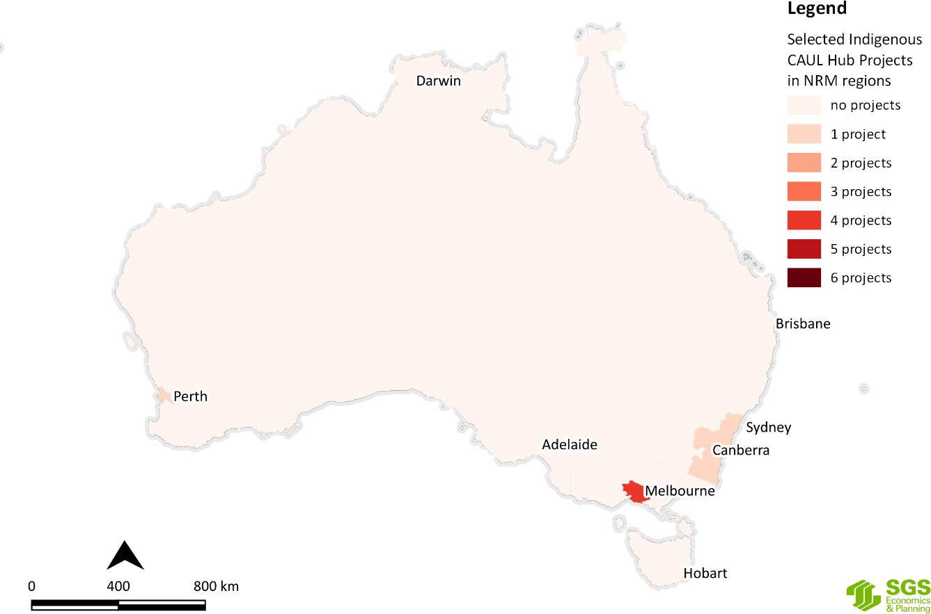
Figure J.25 Selected CAUL Hub research project locations by NRM Regions
Source: SGS Economics and Planning utilising NESP Hub data, 2020
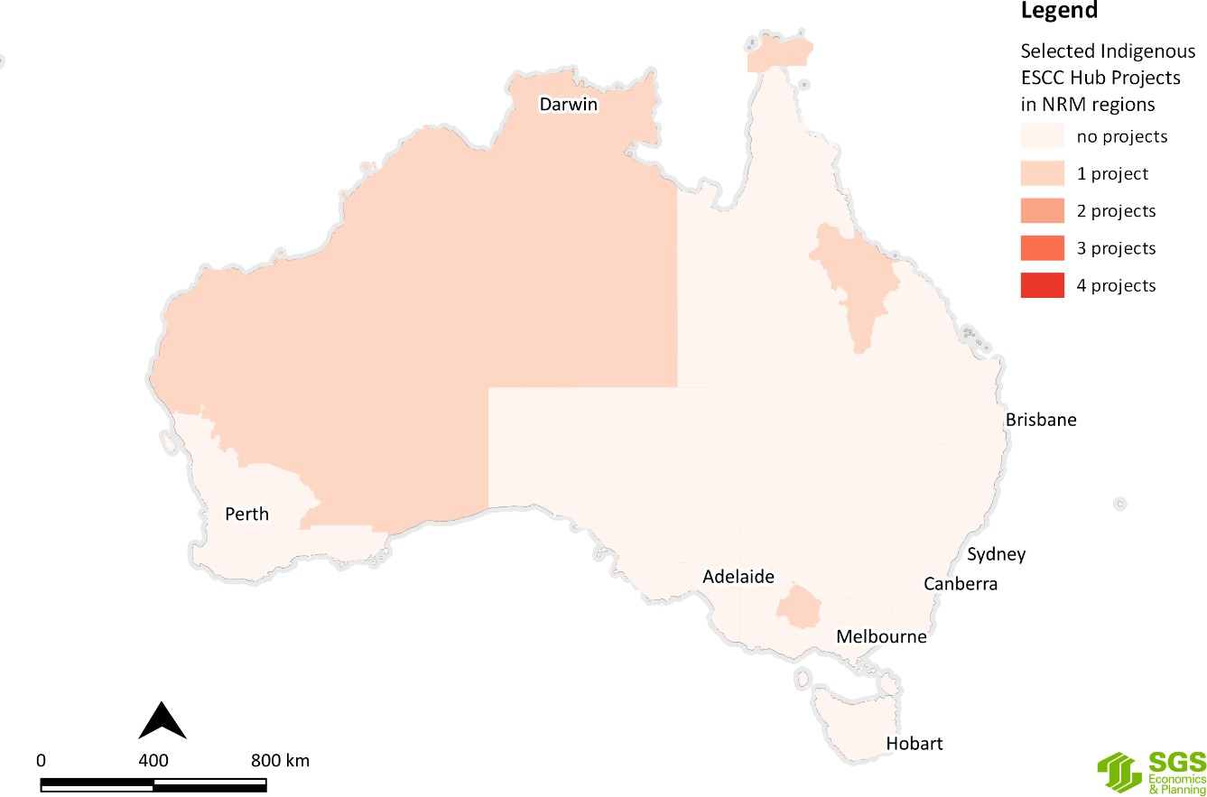
Figure J.26 Selected ESCC Hub research project locations by NRM Regions
Source: SGS Economics and Planning utilising NESP Hub data, 2020

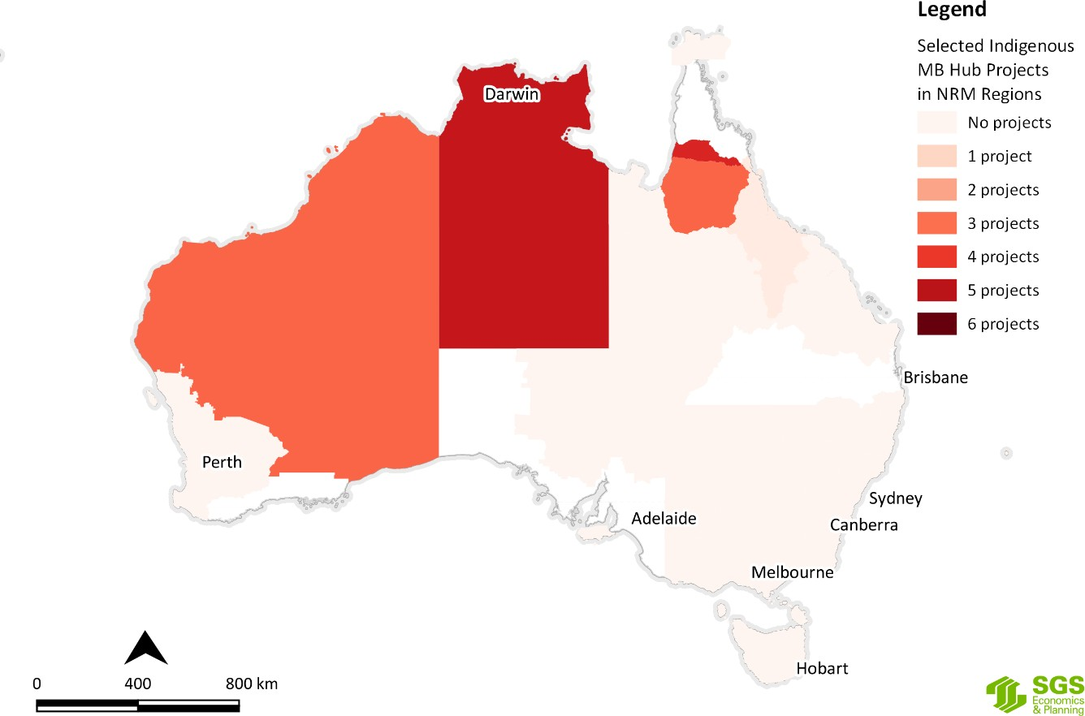
Figure J.27 Selected MB Hub research project locations by NRM Regions
Source: SGS Economics and Planning utilising NESP Hub data, 2020
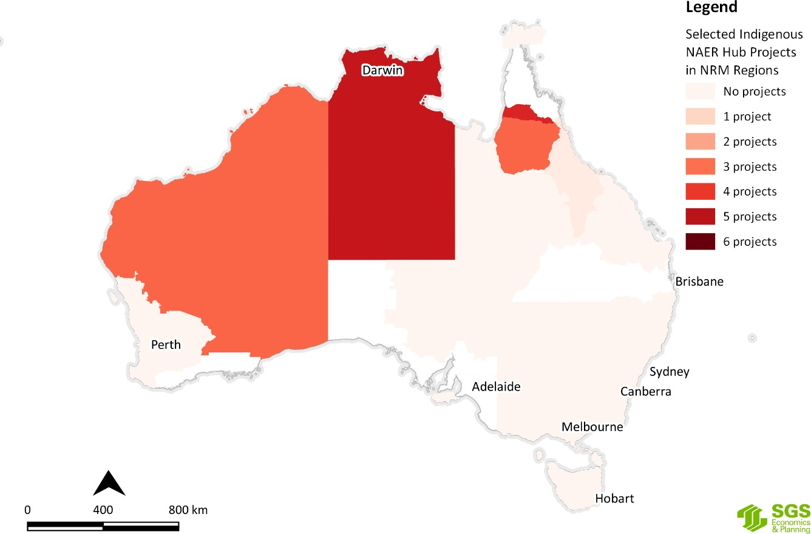
Figure J.28 Selected NAER Hub research project locations by NRM Regions
Source: SGS Economics and Planning utilising NESP Hub data, 2020

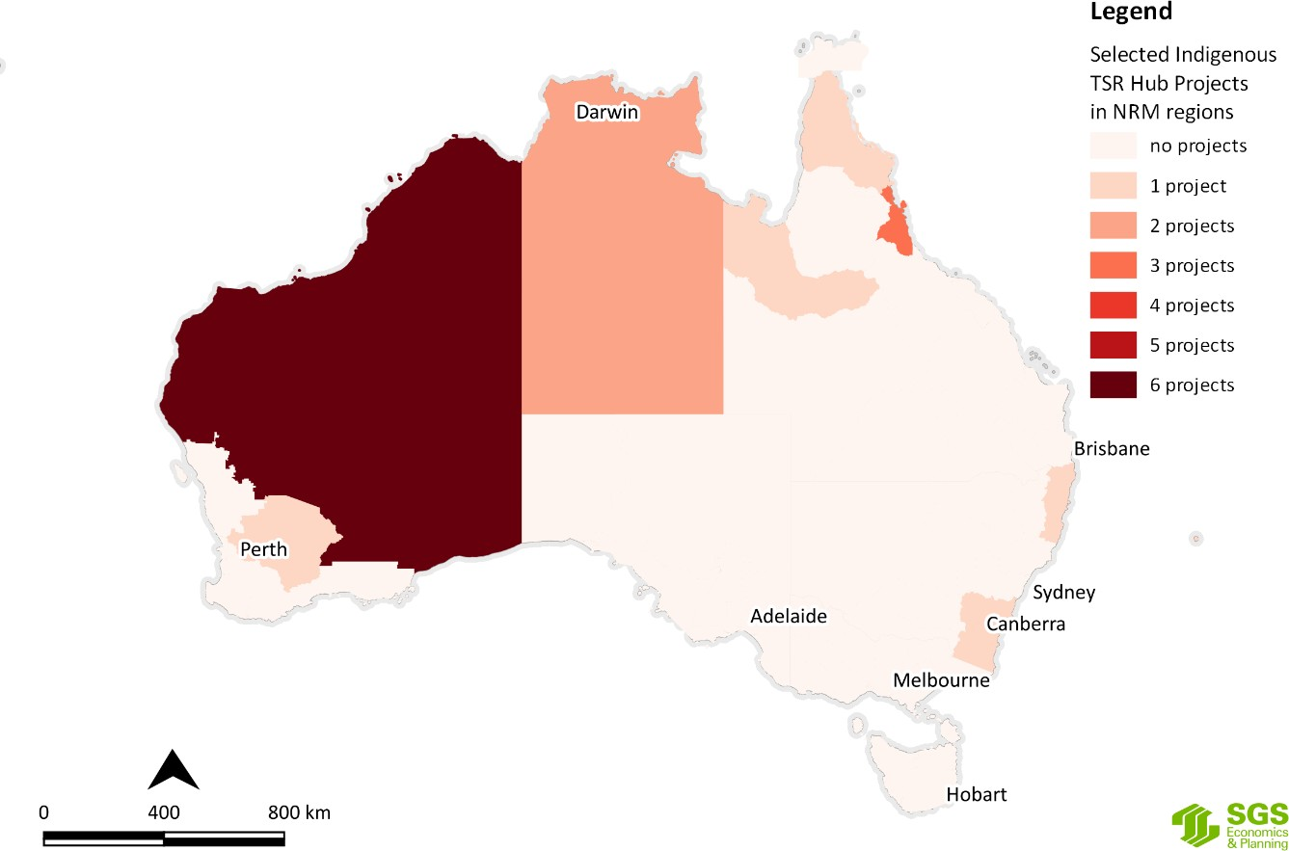
Figure J.29 Selected TSR Hub project locations by NRM Regions
Source: SGS Economics and Planning utilising NESP Hub data, 2020
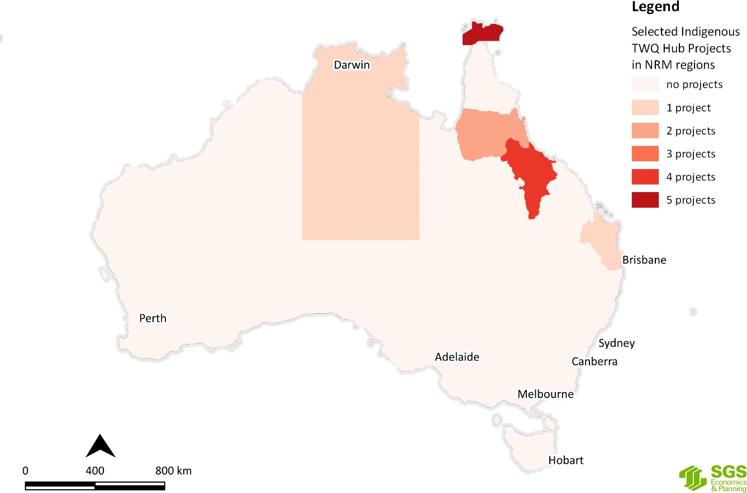
Figure J.30 Selected TWQ Hub research project locations by NRM Regions
Source: SGS Economics and Planning utilising NESP Hub data, 2020

The Indigenous Estate
Recent research has shown that the extent of land owned, managed or controlled by Aboriginal and Torres Strait Islander peoples is increasing over time. This is referred to as the ‘Indigenous estate’ by several academics (Altman and Kerins, 2012; Wensing, 2016) and the Indigenous Property Rights Network (AHRC, 2016). The Indigenous Estate is defined by the Indigenous Property Rights Network as encompassing ‘the lands, seas, waters and resources of Aboriginal and Torres Strait Islander peoples’ (AHRC, 2016:1). The different components of the Indigenous Estate are listed in Appendix L.
Altman’s (2014) research reveals that the extent of the Indigenous estate is around 2.5 million square kilometres or roughly 33 per cent of terrestrial Australia. Figure J.31 shows the extent of the Indigenous estate under three tenures:
- land claimed or automatically scheduled under land rights law (an estimated 969,000 sq kms);
- 92 determinations of exclusive possession under native title law totalling 752,000 sq kms; and
- 142 determinations of non-exclusive possession under native title law totalling 825,000 sq kms.

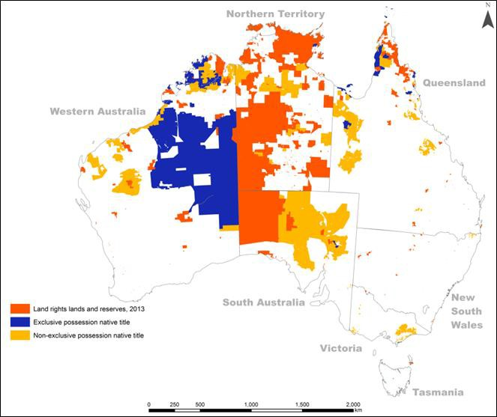
Altman (2014:5) notes that the last category often provides a weak form of property right that needs to be shared with other interests, most commonly commercial rangeland pastoralism. The data to compile these maps was current as at 31 December 2013 and only relates to the terrestrial estate, not marine or offshore waters.
Figure J.31 The Indigenous estate under three land titles (as at 2013)
Source: Altman 2014:6

Altman’s (2014) research also highlights the relationship between three different environmental values
overlaying a template of lands of exclusive land rights and native title possession over Australia.
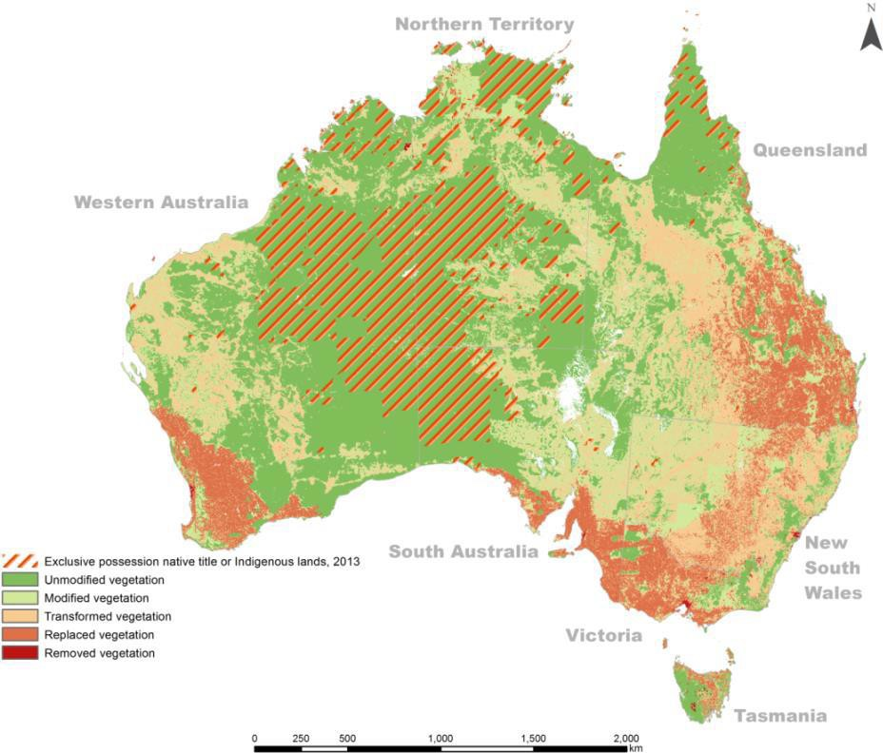Figure J.32 shows a marked contrast between exclusive possession native title and Indigenous lands and vegetation condition.
Figure J.32 Vegetation condition (2006) and exclusive possession native title or Indigenous lands (2013)
Source: Altman 2014:10

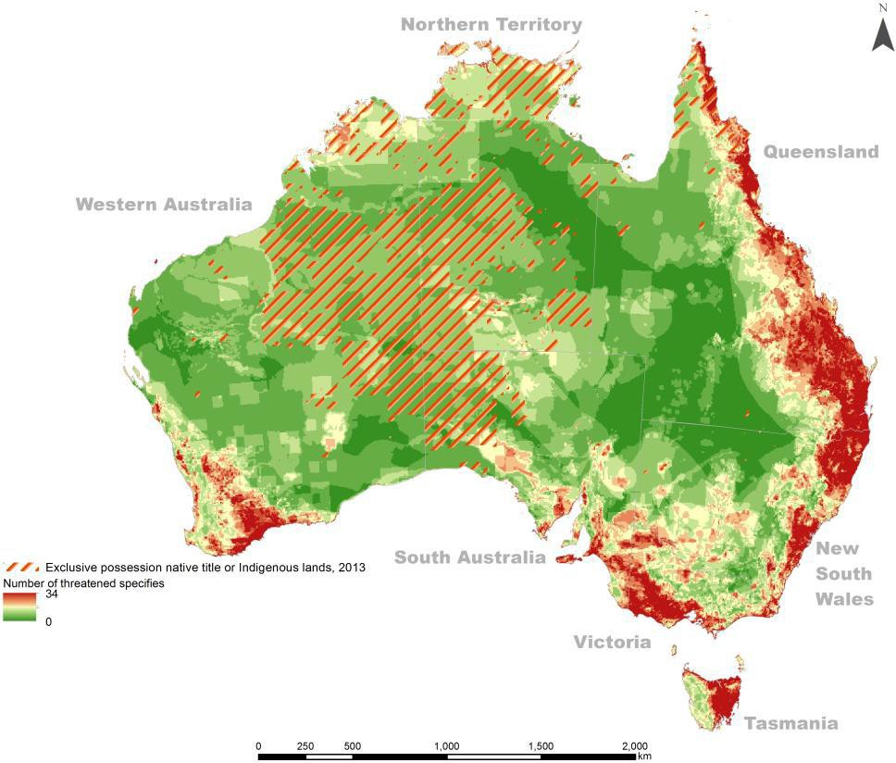Figure J.33 also shows a marked contrast between exclusive possession native title and Indigenous lands and official threatened species counts, particularly in the more densely settled areas in the south east and south west of the continent and in Tasmania.
Figure J.33 Threatened species count (2008) and exclusive possession native title or Indigenous lands (2013)
Source: Altman 2014:10

Figure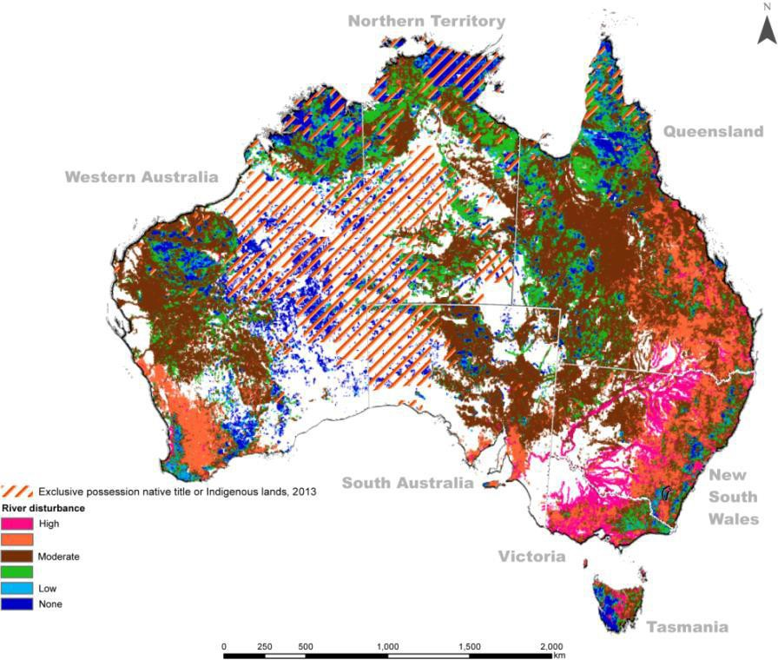 J.34 shows the relationship between exclusive possession native title and Indigenous lands and the riparian zones of rivers, so crucial to biodiversity and water quality. Figure J. 34 also shows a high river disturbance indicator in the south east and south west of the continent, especially along the Murray Darling system. Altman (2014:9) notes that while there has been low disturbance in the remote tropical savannah, this does not necessarily suggest these areas are threat free.
Figure J.34 Disturbance of riparian zones (2008) and exclusive possession native title or Indigenous lands (2013)
Source: Altman 2014:11
Altman notes that because much of the Indigenous estate has high environmental values, it is resulting in more of this land being incorporated into the conservation estate, especially since the mid-1990s when the NRS was created (as discussed in Appendix H).
The extent of the Indigenous estate and national conservation lands in about 2012 when there were only 60 IPAs, is shown in Figure J.35.

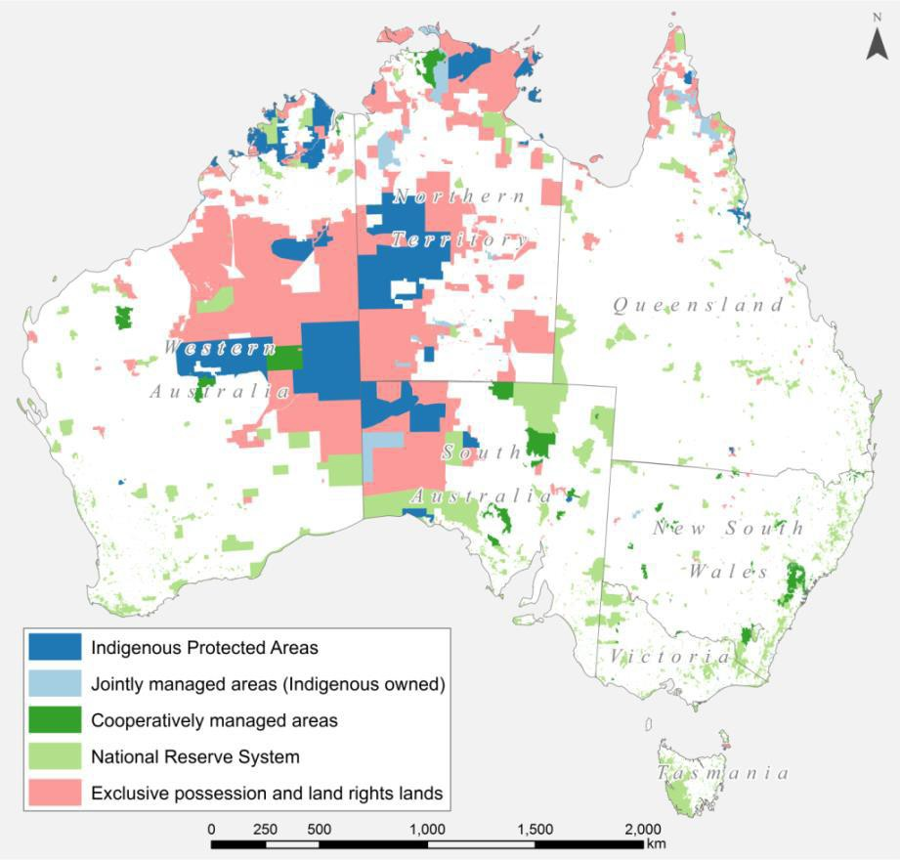

Figure J.35 The Indigenous estate and national conservation lands
Source: Altman 2014:12
Figure J.36 shows diagrammatically the size of Indigenous held land, the NRS, IPAs, jointly managed areas and cooperatively managed areas as proportions of Australia. The data used to compile Figure J.36 was current at 31 December 2013. As discussed in Appendix H, while the NRS and the number of IPAs have increased significantly since then, the proportion of area covered by IPAs, jointly managed or cooperatively managed remain relatively small given the existential threats to Australia’s natural environment (Spratt and Dunlop 2018; ANU 2020). There is potential therefore for more of the Indigenous estate to be added to conservation and biodiversity protection, if Traditional Owners so wish (Altman, 2014:13).
The purpose of Altman’s analysis was to show the correlation between the growing size of the Indigenous
estate and its environmental values. Altman’s (2014:1) analysis focuses on tension between national growth (as measured by gross domestic product dependent on industrial extraction of minerals and commodity exports) and local and regional development for Indigenous landowners. Altman (2014) argues that while the tension is based on a different focus on livelihoods and wellbeing, there is potential for the commodification of the provision of environmental and other ecosystem services on the Indigenous estate.

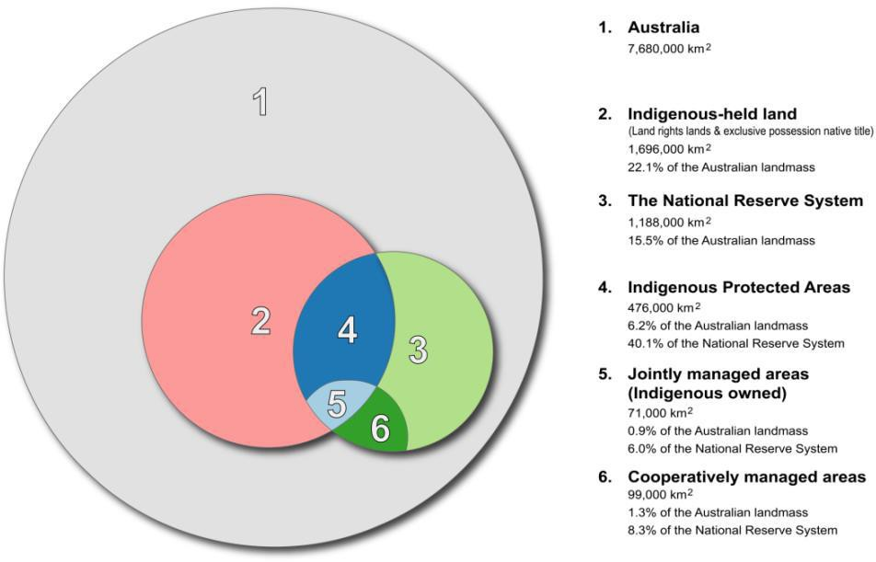
Figure J.36 Indigenous and other components of the terrestrial conservation estate
Source: Altman 2014:13
As discussed in Appendix H, ABARES prepares a periodic State of the Forests Report (SoFR) which includes as a key indicator (Indicator 6.4a): the area of forest to which Indigenous people have use and rights that protect their special values and which are recognised through formal and informal management regimes.
ABARES believes that an essential part of forest management is an acceptable level of accountability for the
protection of Indigenous peoples’ cultural, religious, social and spiritual needs and values.
In order to report against this indicator, ABARES collates information on land under Indigenous ownership, management or control and groups this information into the following four categories (Dillon et al, 2015):
- Indigenous owned and managed: freehold land that are both owned and managed by Indigenous persons, entities or organisations.
- Indigenous managed: land that are managed but not owned by Indigenous people, entities or organisations (e.g. Crown reserves and leases); and lands that are owned by Indigenous people, but have formal shared management agreements with Australian and state and territory government agencies (e.g. leased-back nature conservation reserves).
- Indigenous co-managed: land that are owned and managed by other parties, but have formal, legally binding agreements in place to include input from Indigenous people in the process of developing and implementing a management plan (e.g. nature conservation reserve memoranda of understanding).
- Other special rights: land subject to native title determinations (exclusive possession or non- exclusive possession), registered Indigenous Land Use Agreements and legislated special cultural use provisions. These are independent of tenure and, in most cases, do not grant ownership or management rights of land to Indigenous communities. They can provide for the right to access areas of cultural significance or the use of areas for cultural purposes (e.g. within protected water supply catchment areas), or can provide a legal requirement for consultation with the local Indigenous community before any major development or other activities can take place.
SGSEP was able to access the ABARES database on the Indigenous estate and has mapped the Indigenous NESP Hub research project locations against each of these four categories. What follows is a series of several

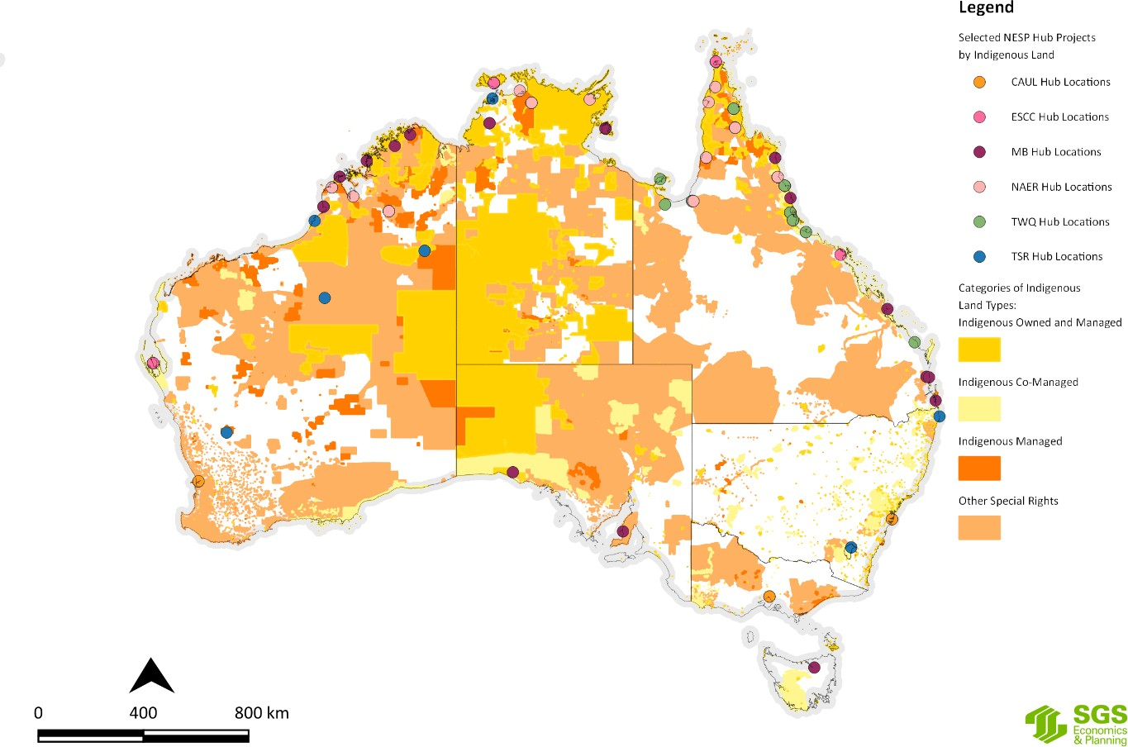maps (Figure J.37 to Figure J.43) showing the selected NESP Hubs research project locations against each of the four Indigenous land categories.
Figure J. 37 Selected NESP Hub research projects by Indigenous lands
Source: SGS Economics and Planning utilising ABARES and NESP Hub data, 2020

Indigenous owned and managed land
That is freehold land which is both owned and managed by Indigenous people, entity or organisation. Figure J.38 to Figure J.43 show the NESP Hub Indigenous research project localities against Indigenous owned and managed lands.

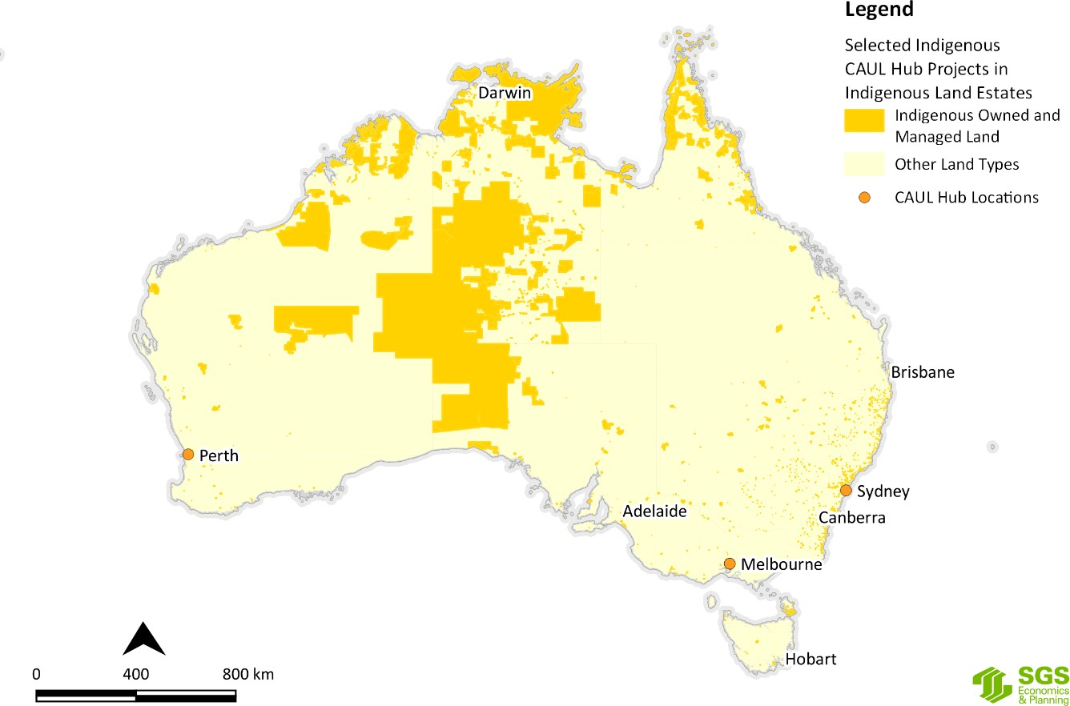
Figure J.38 Selected CAUL Hub research project locations by Indigenous owned and managed land
Source: SGS Economics and Planning utilising ABARES and NESP Hub data, 2020
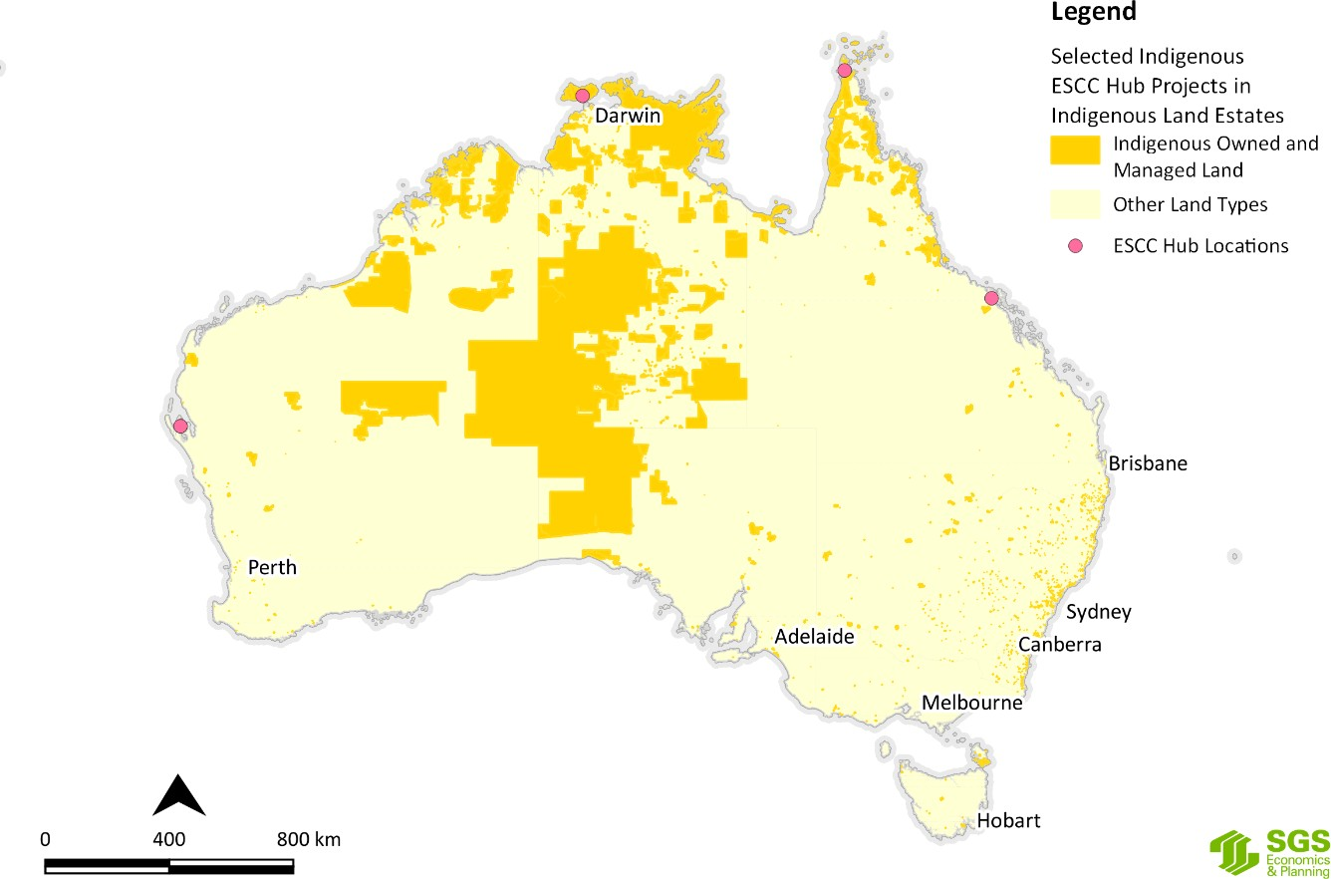
Figure J.39 Selected ESCC Hub research project locations by Indigenous owned and managed land
Source: SGS Economics and Planning utilising ABARES and NESP Hub data, 2020

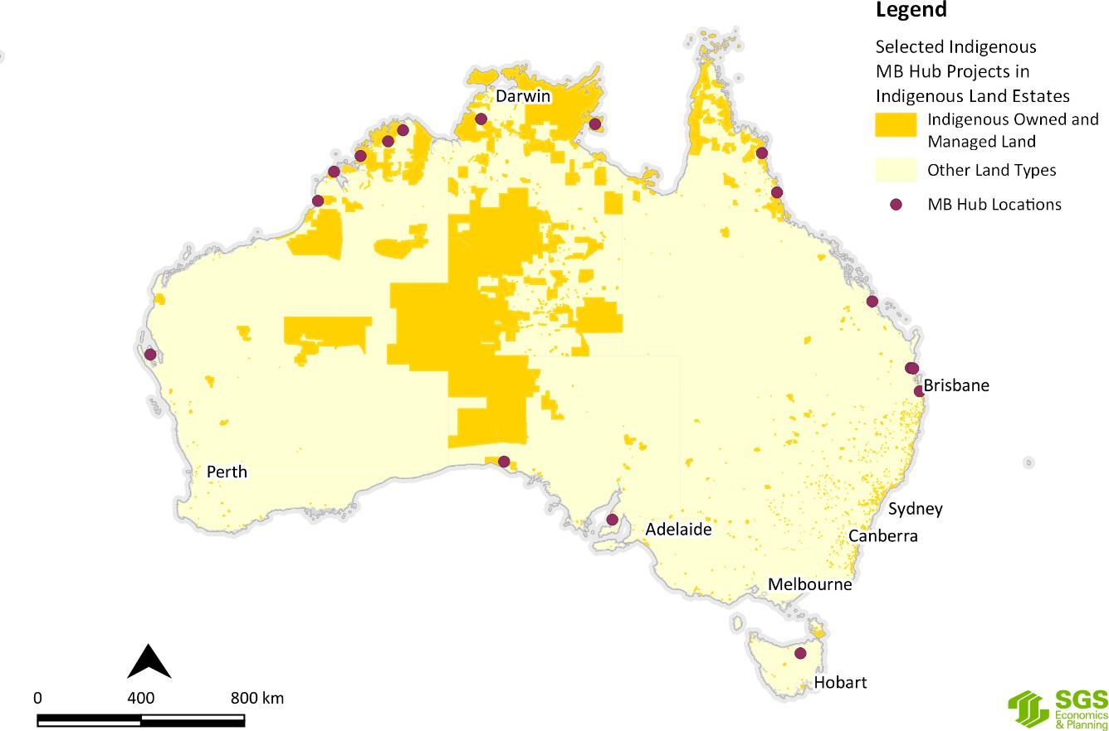
Figure J.40 Selected MB Hub research project locations by Indigenous owned and managed land
Source: SGS Economics and Planning utilising ABARES and NESP Hub data, 2020
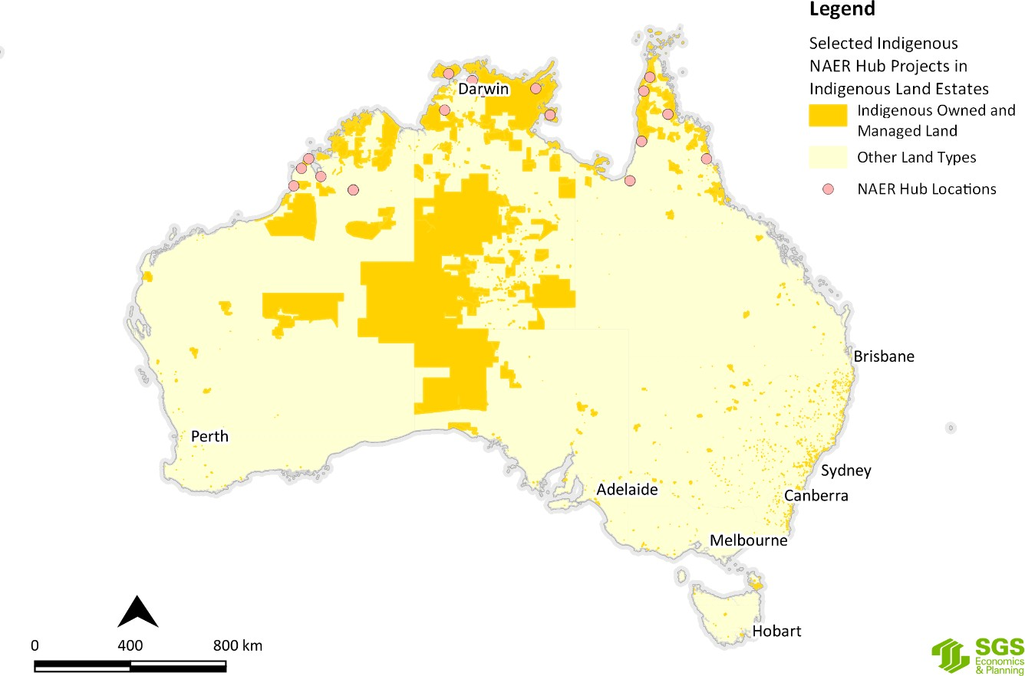
Figure J.41 Selected NAER Hub research project locations by Indigenous owned and managed land
Source: SGS Economics and Planning utilising ABARES and NESP Hub data, 2020

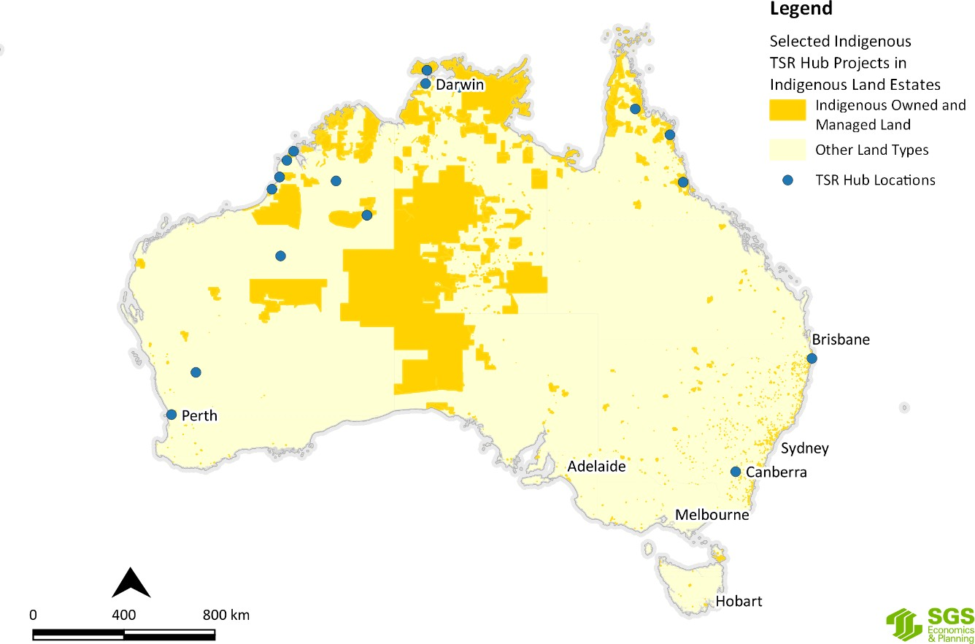
Figure J.42 Selected TSR Hub research project locations by Indigenous owned and managed land
Source: SGS Economics and Planning utilising ABARES and NESP Hub data, 2020
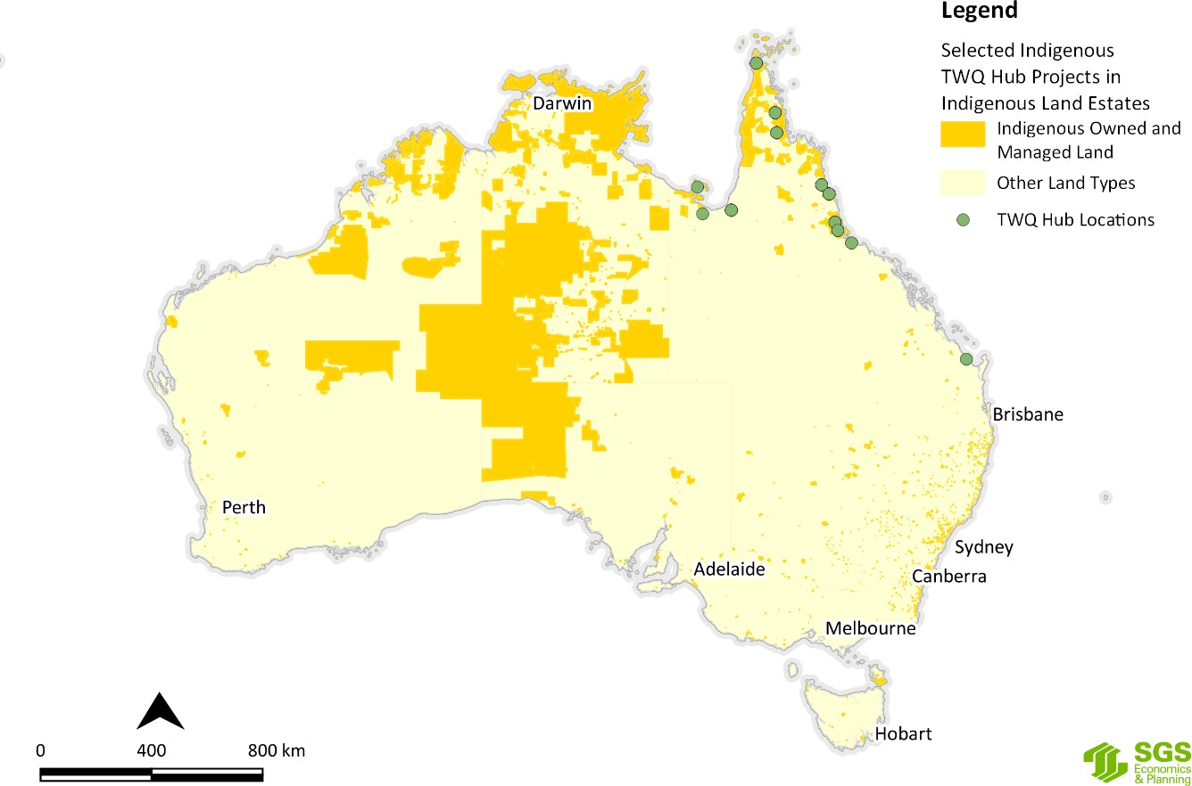
Figure J.43 Selected TWQ Hub research project locations by Indigenous owned and managed land
Source: SGS Economics and Planning utilising ABARES and NESP Hub data

Indigenous managed land
That is land which is managed but not owned by Indigenous people, entities or organisations (e.g. Crown reserves and leases); and lands that are owned by Indigenous people, but have formal shared management agreements with Australian and state and territory government agencies (e.g. leased-back nature conservation reserves).
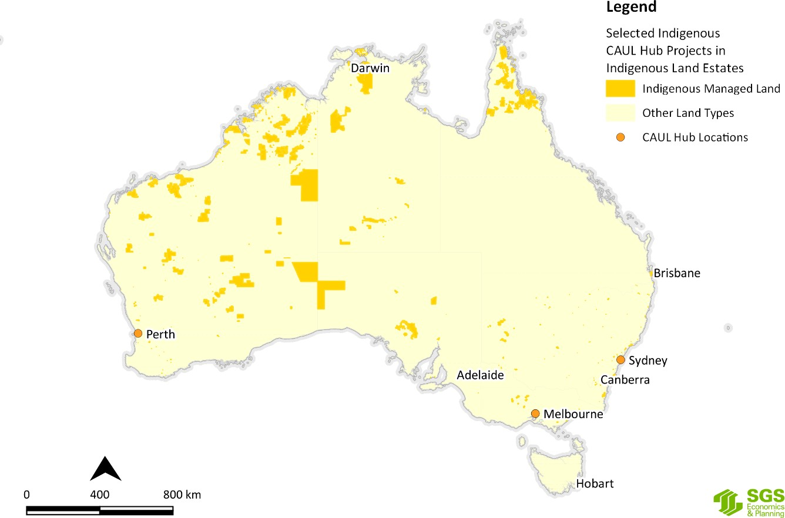Figure J.44 to Figure J.49 show the NESP Hub Indigenous research project localities against Indigenous managed lands
Figure J.44 Selected CAUL Hub research project locations by Indigenous managed land
Source: SGS Economics and Planning utilising ABARES and NESP Hub data, 2020

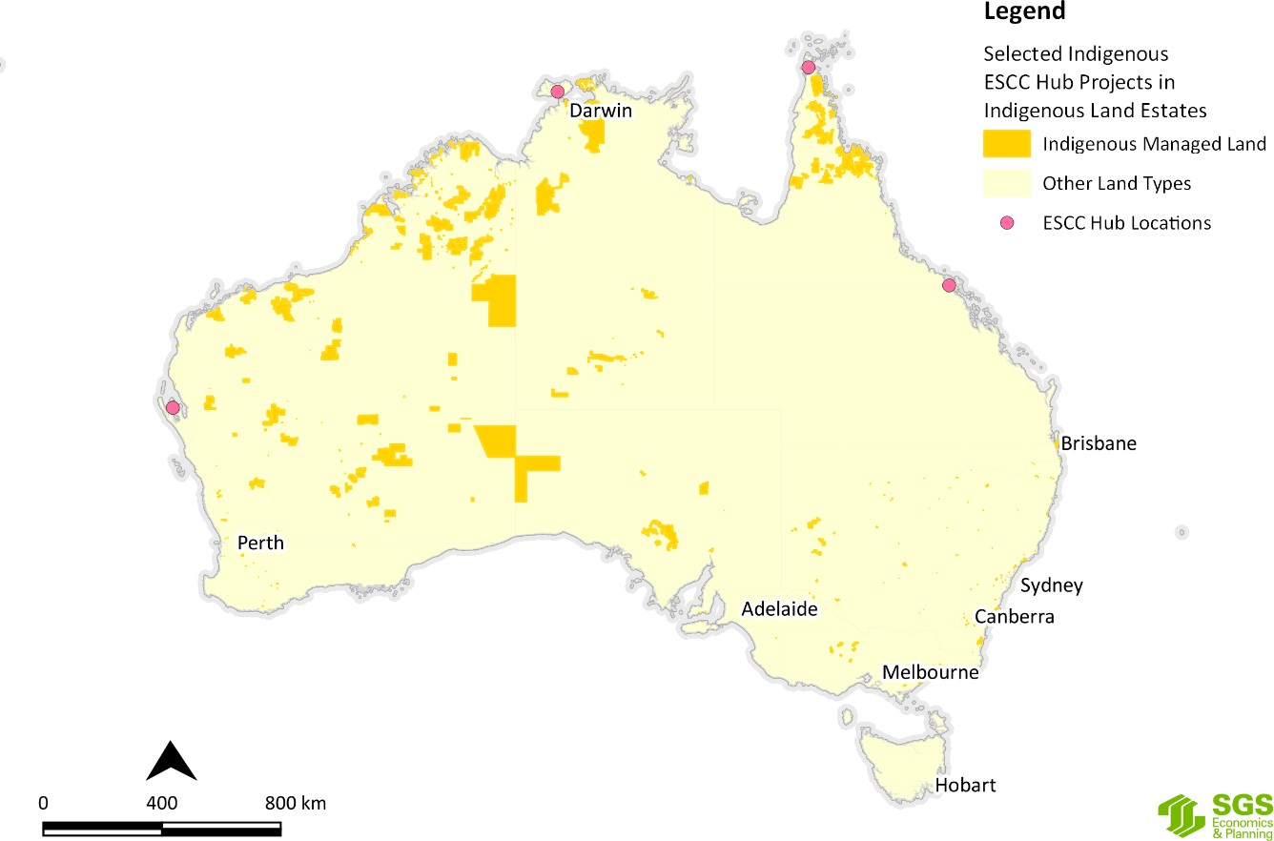
Figure J.45 Selected ESCC Hub research project locations by Indigenous managed land
Source: SGS Economics and Planning utilising ABARES and NESP Hub data, 2020
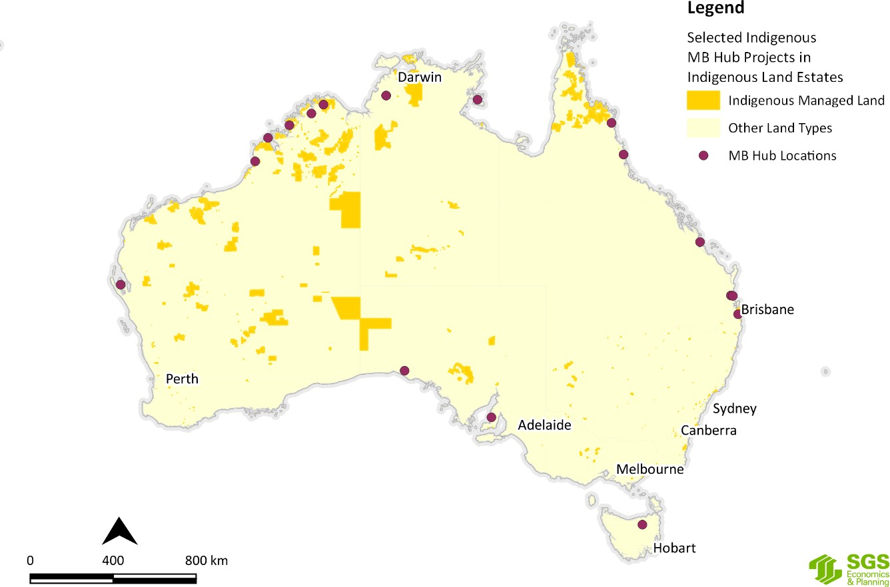
Figure J.46 Selected MB Hub research project locations by Indigenous managed land
Source: SGS Economics and Planning utilising ABARES and NESP Hub data, 2020

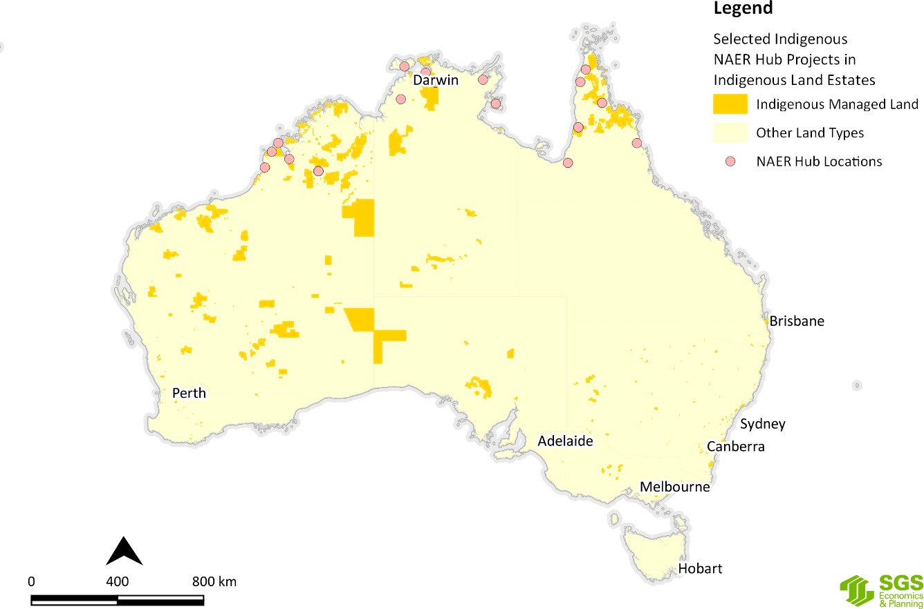
Figure J.47 Selected NAER Hub research project locations by Indigenous managed land
Source: SGS Economics and Planning utilising ABARES and NESP Hub data, 2020
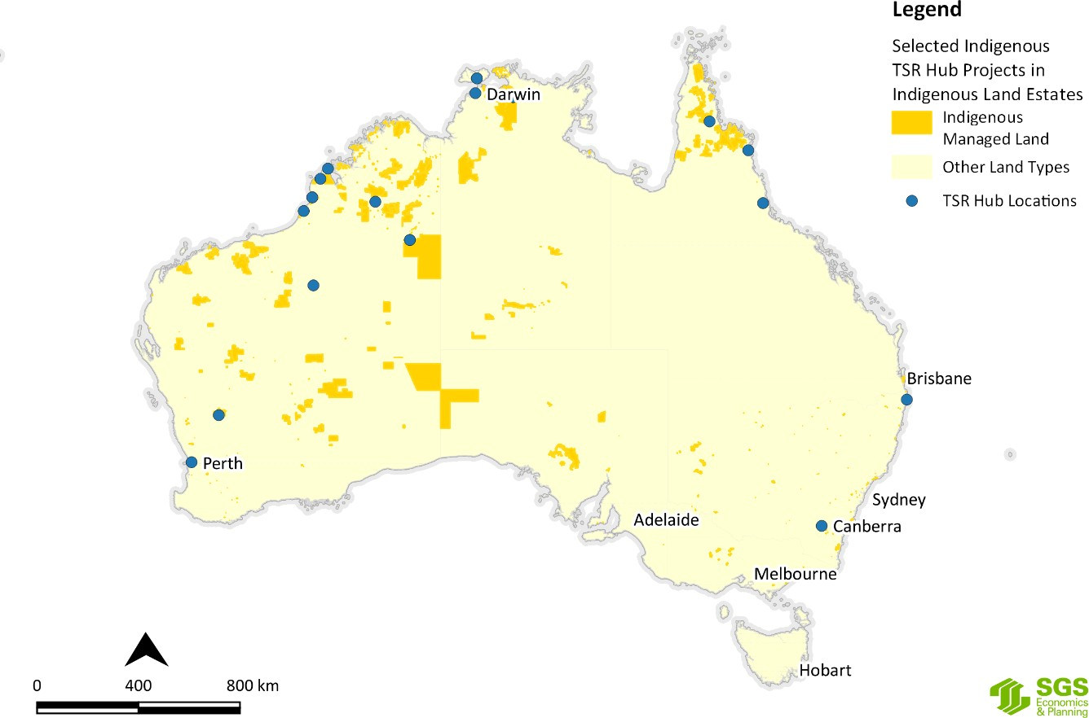
Figure J.48 Selected TSR Hub research project locations by Indigenous managed land
Source: SGS Economics and Planning utilising ABARES and NESP Hub data, 2020

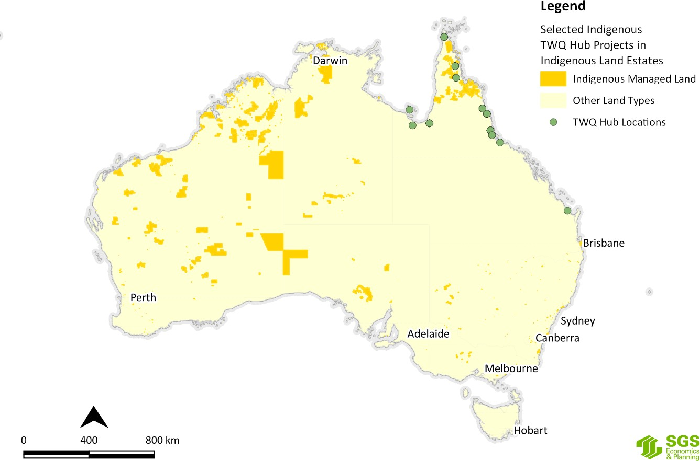
Figure J.49 Selected TWQ Hub research project locations by Indigenous managed land
Source: SGS Economics and Planning utilising ABARES and NESP Hub data

Indigenous co-managed land
Indigenous co- managed land is land which is owned and managed by other parties, but have formal, legally binding agreements in place to include input from Indigenous people in the process of developing and implementing a management plan (e.g. nature conservation reserve memoranda of understanding).
Figure J.50 to Figure J.55 show the NESP Hub Indigenous research project localities against Indigenous co- managed lands.

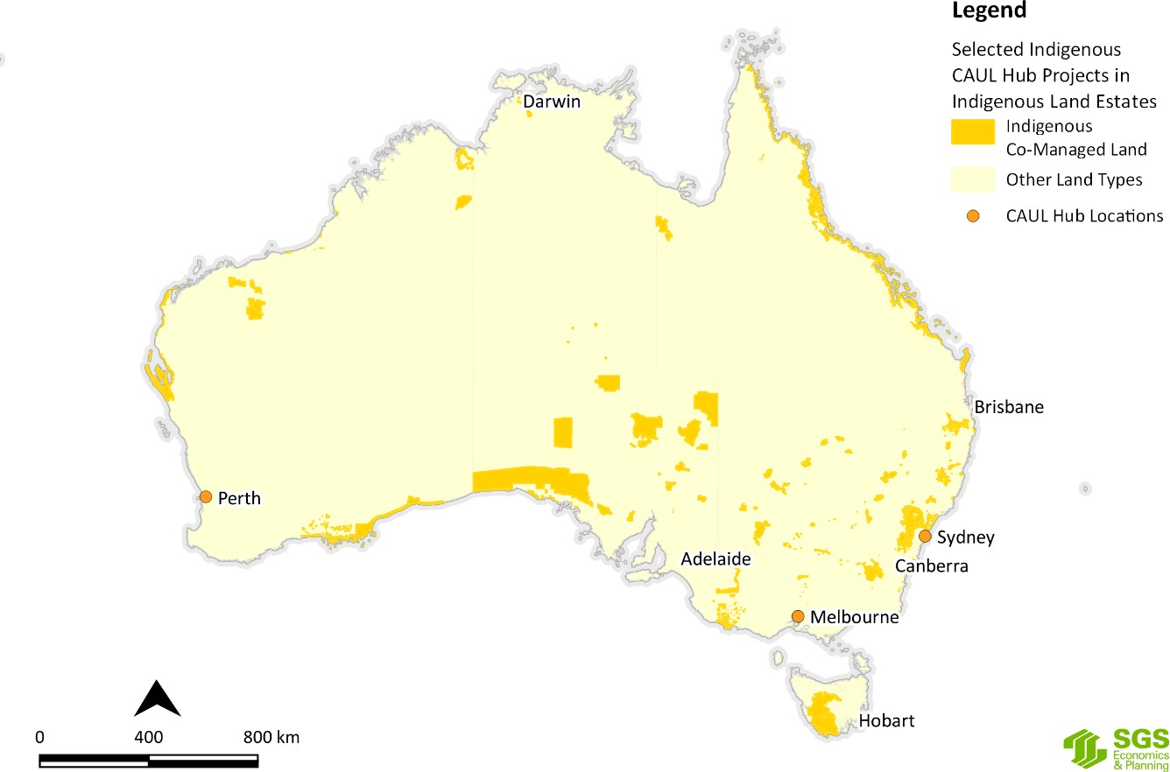

Figure J.50 Selected CAUL Hub research project locations by Indigenous co-managed land
Source: SGS Economics and Planning utilising ABARES and NESP Hub data, 2020
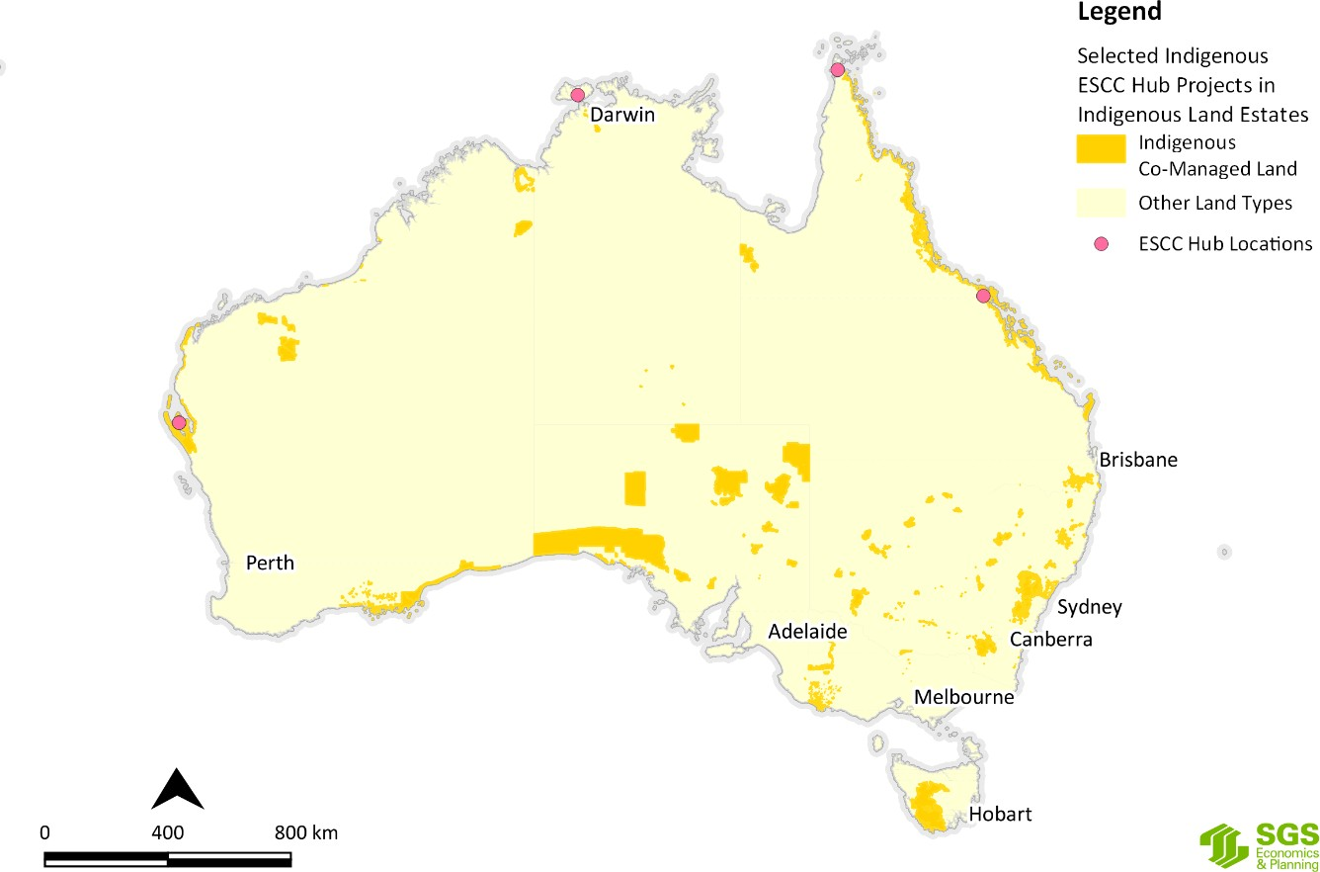
Figure J.51 Selected ESCC Hub research project locations by Indigenous co-managed land
Source: SGS Economics and Planning utilising ABARES and NESP Hub data, 2020

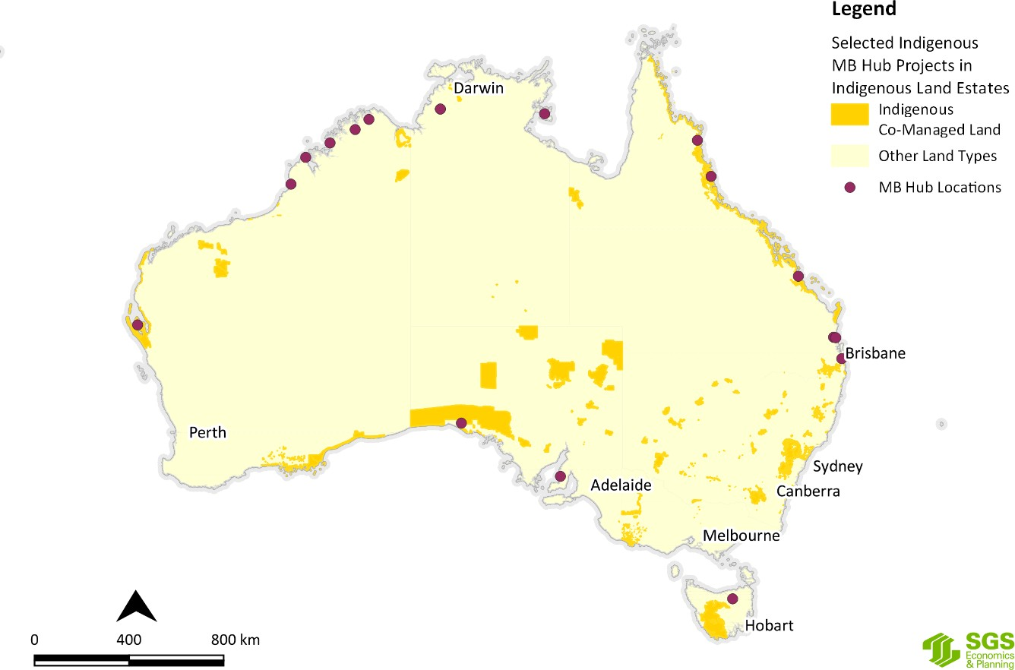
Figure J.52 Selected MB Hub research project locations by Indigenous co-managed land
Source: SGS Economics and Planning utilising ABARES and NESP Hub data, 2020
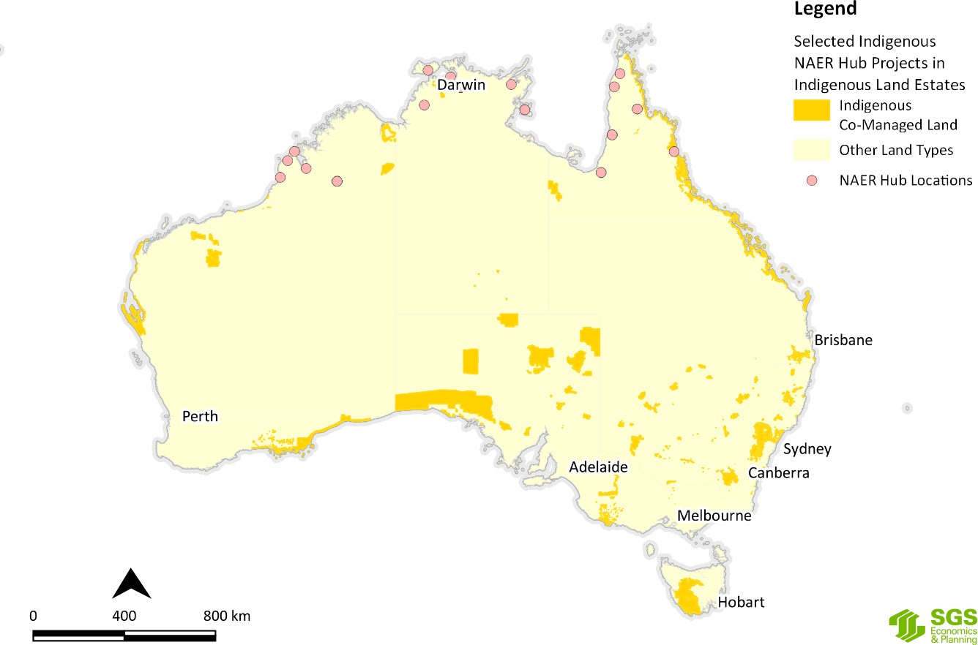
Figure J.53 Selected NAER Hub research project locations by Indigenous co-managed land
Source: SGS Economics and Planning utilising ABARES and NESP Hub data, 2020

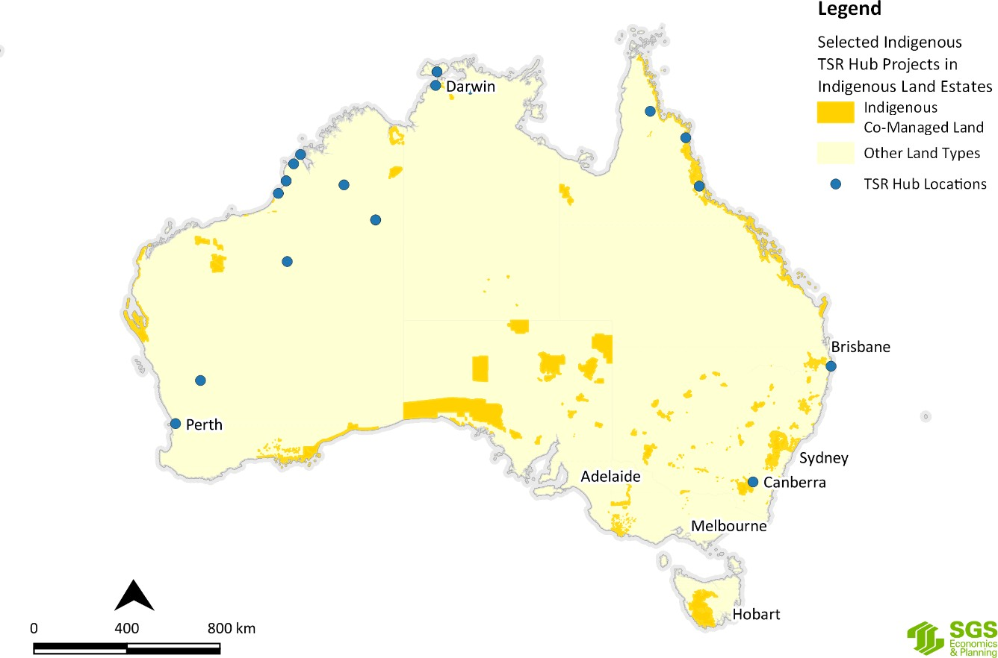

Figure J.54 Selected TSR Hub research project locations by Indigenous co-managed land
Source: SGS Economics and Planning utilising ABARES and NESP Hub data, 2020
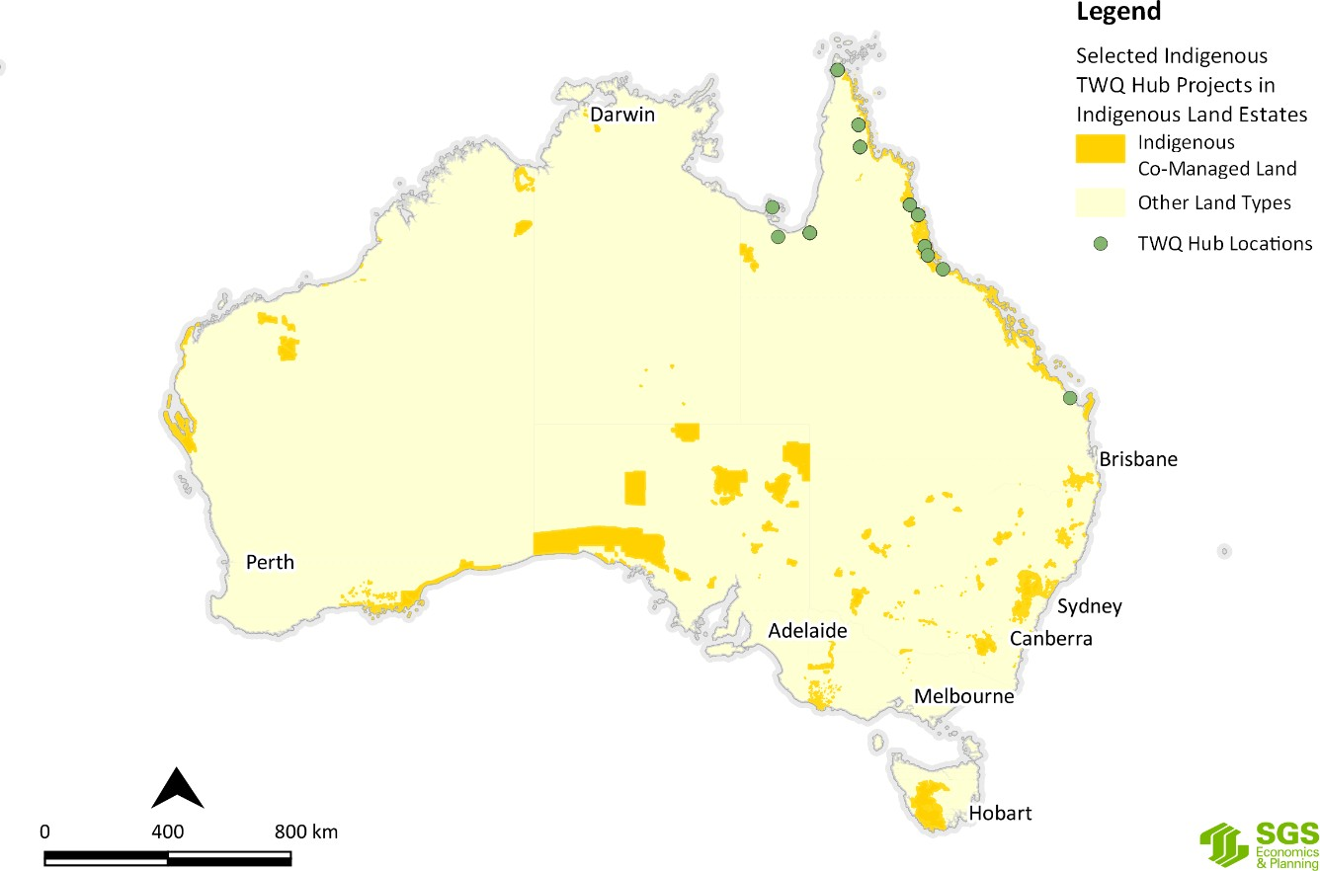
Figure J.55 Selected TWQ Hub research project locations by Indigenous co-managed lands
Source: SGS Economics and Planning utilising ABARES and NESP Hub data, 2020

Indigenous special rights (i.e. native title determinations).
That is land which is subject to a native title determination (exclusive possession or non-exclusive possession), a registered Indigenous Land Use Agreement or legislated special cultural use provisions. These are independent of tenure and, in most cases, do not grant ownership or management rights of land to Indigenous communities. These arrangements can provide for the right to access areas of cultural significance or the use of areas for cultural purposes (e.g. within protected water supply catchment areas), or can provide a legal requirement for consultation with the local Indigenous community before any major development or other activities can take place.
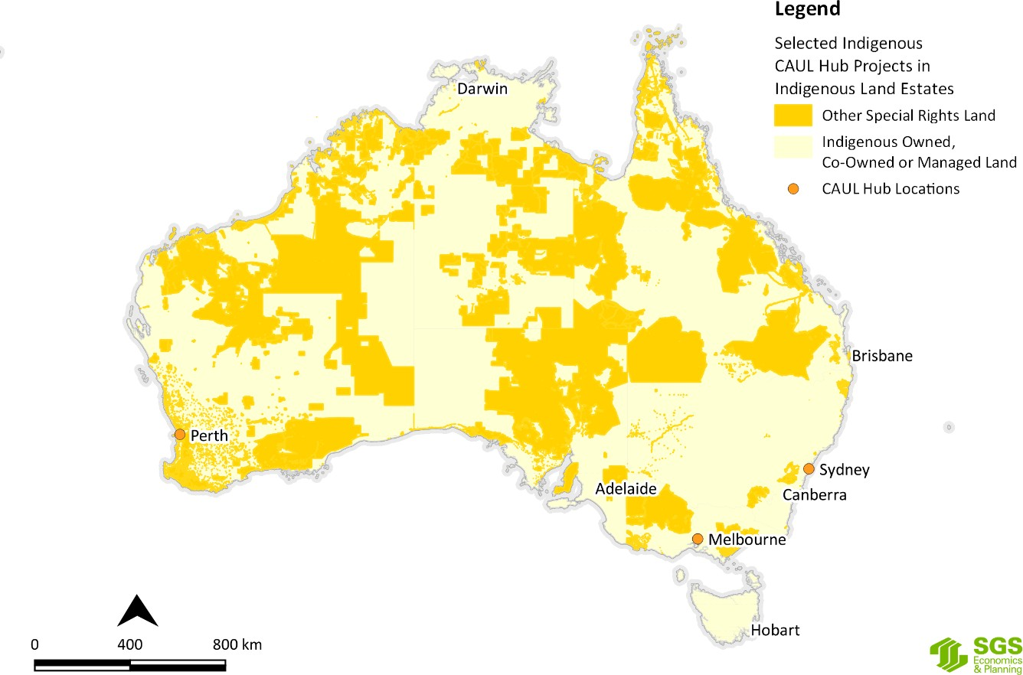Figure J.56 to Figure J.61 show the NESP Hub Indigenous research project localities against Indigenous special rights.
Figure J.56 Selected CAUL Hub research project locations by Indigenous special rights land
Source: SGS Economics and Planning utilising ABARES and NESP Hub data, 2020

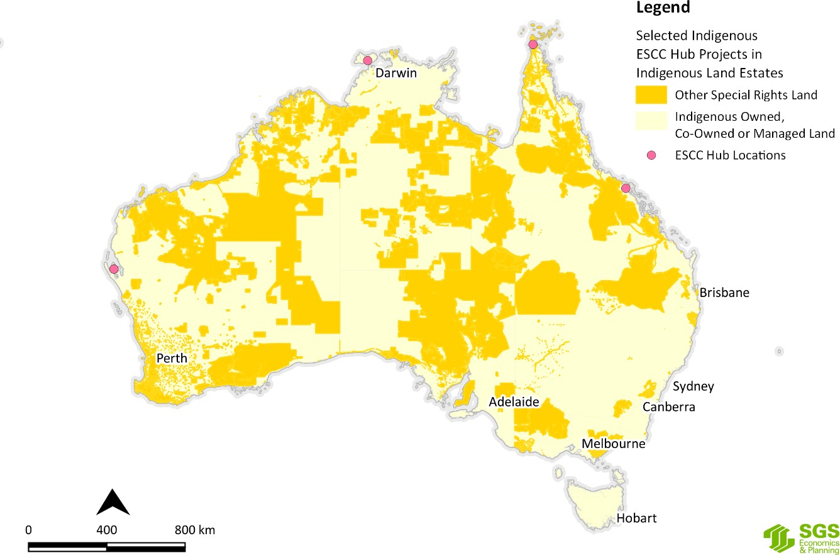
Figure J.57 Selected ESCC Hub research project locations by Indigenous special rights land
Source: SGS Economics and Planning utilising ABARES and NESP Hub data, 2020
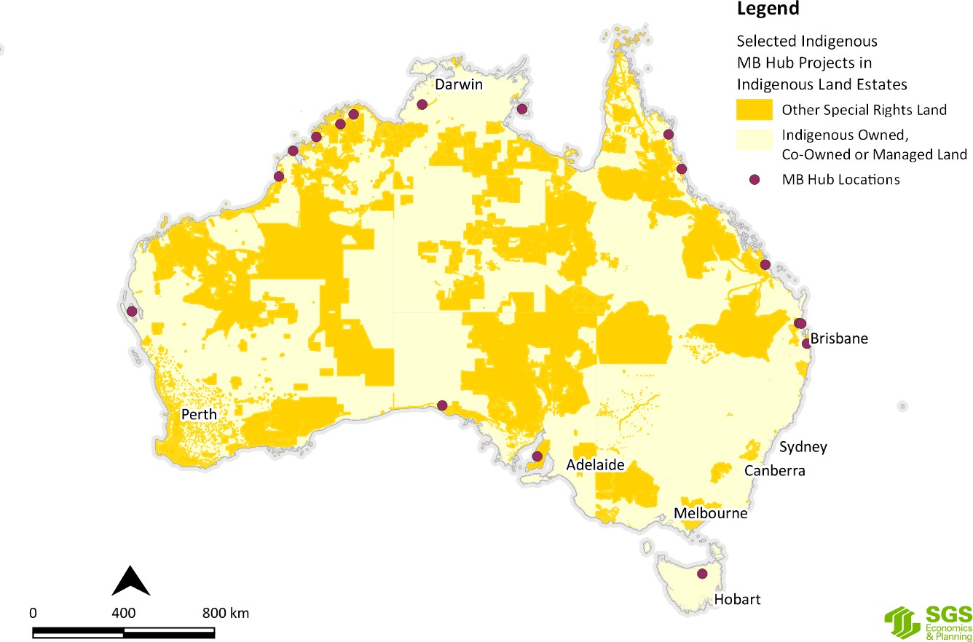
Figure J.58 Selected MB Hub research project locations by Indigenous special rights land
Source: SGS Economics and Planning utilising ABARES and NESP Hub data, 2020

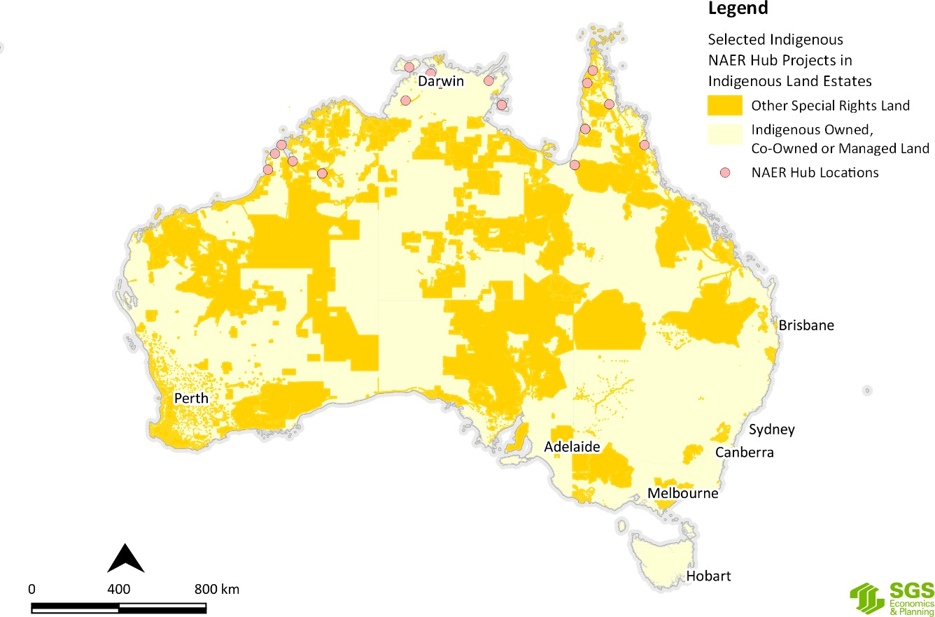
Figure J.59 Selected NAER Hub research project locations by Indigenous special rights land
Source: SGS Economics and Planning utilising ABARES and NESP Hub data, 2020
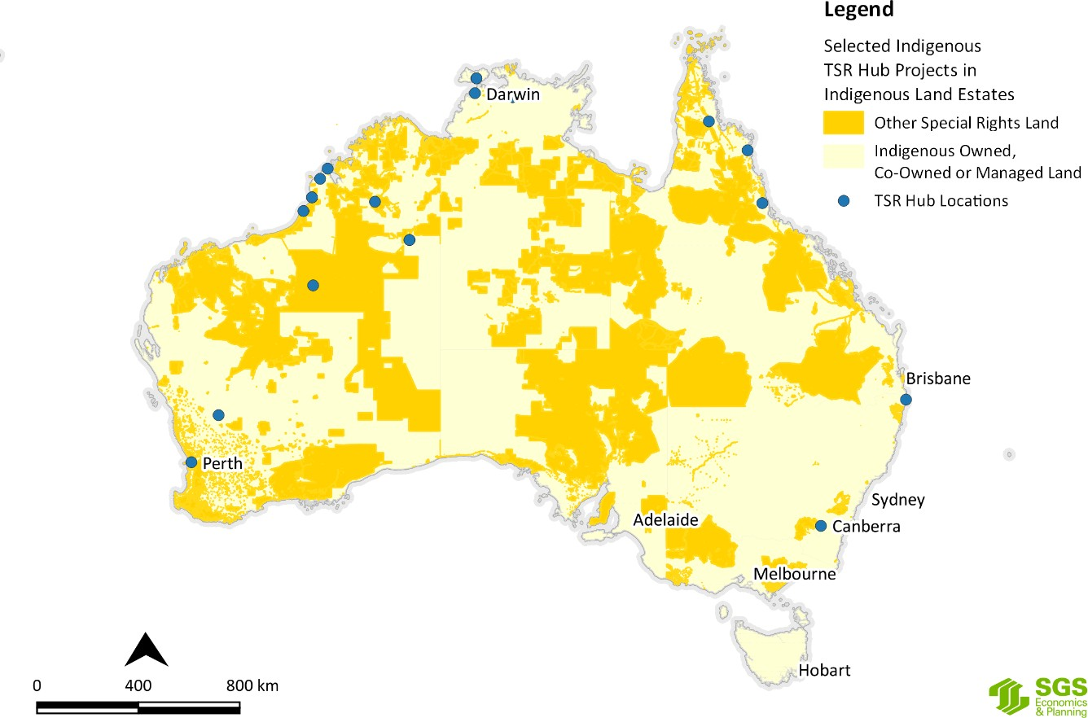
Figure J.60 Selected TSR Hub research project locations by Indigenous special rights land
Source: SGS Economics and Planning utilising ABARES and NESP Hub data, 2020

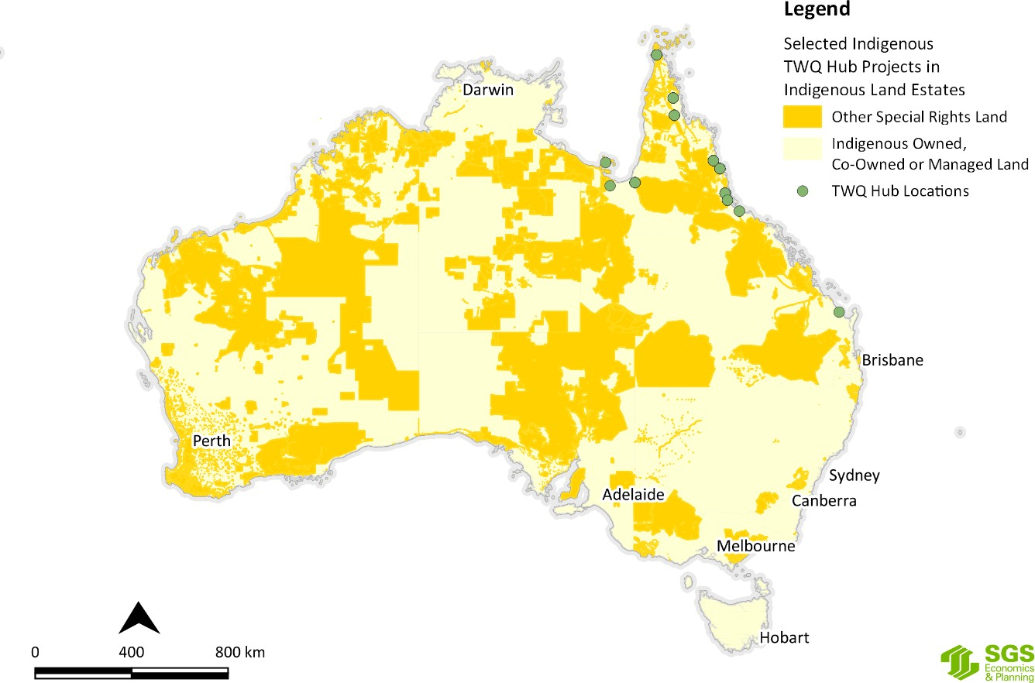
Figure J.61 Selected TWQ Hub research project locations by Indigenous special rights land
Source: SGS Economics and Planning utilising ABARES and NESP Hub data, 2020
By necessity, the maps in Figure J.56 to Figure J.61 focus on the macroscopic and continental scale and are not intended to focus on the local scale. Nevertheless, it is possible to make the observation that there is a reasonable correlation between the location of NESP Hub projects and Indigenous owned and/or managed lands of one kind or another. But having drawn that general observation, SGSEP hastens to add that this is an area where further investigation is required in consultation with the Indigenous people and entities that have interests in land to ascertain with greater clarity what their environmental and climate science research themes and questions may be.

